Wearable Device for Situational Awareness Using Stereo Sound

EGH400 Honours Thesis Capstone Project

**by Theo Pengelly**

N9872281

**Supervisors**

Doctor Ajay Pandey

Professor Wageeh Boles

Presented 3 November 2019

# Abstract

This document presents a technique for increasing situational awareness for the vision impaired, and a prototype of a device to utilise such a technique. A head-mounted Intel RealSense D435i camera is used to capture a depth “image” in front of the user once triggered, with a horizontal field of view of approximately 80 degrees. Samples are taken from the horizon of this depth image, and three audio localisation pointers are produced utilising “clap” sounds, with each sound panned in stereo to represent their azimuth relative to the user and delayed by an amount of time proportional to the distance. The device also provides obstacle warning tones for 10 seconds after the device is triggered, based on 3 classifications of obstacle proximity.

Processing of the depth information is performed using a Raspberry Pi system running Ubuntu MATE. Sound output is performed using the ALSA audio libraries, and a technique for producing low-latency sound output for the audio localisation pointers is presented. Techniques for filtering and segmenting the depth information utilising edge detection have been explored and detailed.

A physical prototype has been produced utilising a Raspberry Pi 3B+ system. The device is “on-demand” (only producing audio when the user requests it) and user input is through a Logitech wireless USB pointer. The device is powered by a USB battery supply. Power usage has been profiled and improvements implemented and quantified; however, overall battery life remains problematic.

The navigational effectiveness of the device is reasonable: some awareness of the shape of the room or passage is given, and navigation of hallways and rooms is possible. The obstacle warning system greatly assists the navigational process by allowing the user to “scan” the room for openings or obstacles. The device is limited by full light performance, field of view, and the ability to differentiate the azimuth in stereo sounds. Proposals to improve limitations and extend the usage of the device are provided.

# Table of Contents

1 Abstract ii

2 Table of Contents iii

3 Introduction 1

3.1 Project Overview 1

3.2 Literature Review 1

3.2.1 Existing Navigational Techniques for the Vision Impaired 1

3.2.2 Existing Electronic Aids for the Vision Impaired 2

3.2.3 Binaural Localisation 3

4 Approach 6

4.1 Base Case 6

4.2 Real-Time Extension 8

5 Hardware Implementation 9

5.1 Hardware Overview 9

5.2 Device Firmware 9

5.3 Construction 9

5.4 Connectivity 11

5.5 Bill of Materials 11

6 Software Implementation 12

6.1 Environment and Toolset Overview 12

6.2 Architecture Overview 12

6.3 Input Handling 13

6.4 Depth Capture, Sampling, and Processing 14

6.4.1 Depth Capture 14

6.4.2 Filtering 14

6.5 Depth Image Segmentation 17

6.5.1 Segmentation Using Laplacian and Fill 17

6.5.2 Classification for Obstacle Warnings 19

6.5.3 Alternative Segmentation and Classification Approaches 19

6.6 Localisation Pointer Creation 22

6.7 Sound Output 24

6.7.1 Audio Data 24

6.7.2 Audio Parameters and ALSA Setup 24

6.7.3 ALSA Usage 25

6.7.4 Audio Workflow 26

6.7.5 Startup Sound 28

6.8 Other Usage Considerations 28

6.8.1 Visualisation 28

6.8.2 Power Usage and Management 28

7 Evaluation 31

7.1 Navigational and Spatial Awareness Performance 31

7.2 Software Performance 32

7.3 Physical Device 32

7.4 Comfort 32

7.5 Limitations 33

8 Future Work 34

8.1 Implementation Improvements 34

8.1.1 Other Filtering Approaches 34

8.2 Physical Device and Usability Improvements 35

8.2.1 Construction Improvements 35

8.2.2 Full Light Performance 35

9 Project Management Methodology 37

9.1 First Semester Schedule Progress 37

9.2 Second Semester Progress 38

9.3 Second Semester Proposed Schedule **Error! Bookmark not defined.**

10 Conclusions 39

11 References 40

12 Appendix A – Semester 1 Gantt Chart 42

13 Appendix B – Semester 2 Gantt Chart 44

14 Appendix C – Code 45

14.1 thesis.cpp **Error! Bookmark not defined.**

14.2 cv-helpers.cpp **Error! Bookmark not defined.**

14.3 CMakeLists.txt **Error! Bookmark not defined.**

# Introduction

## Project Overview

This document describes a wearable device to increase situational awareness for the vision impaired. It utilises an Intel RealSense depth camera to capture a depth “image” and samples within this image to determine the depth at three angles. A sound is played for each of these depth samples through stereo headphones. The distance from the user is communicated through delaying the sounds by an amount proportional to the distance, and the angle of each sample is signified by panning the sounds left or right in stereo.

The primary use case of such a device is to assist the vision impaired to navigate environments, and to provide spatial awareness for the range 2-10m from the user. Other use cases may extend to other circumstances where vision is unavailable, but audio is, such as navigation of confined spaces. The approach taken to processing depth and producing audio localisation pointers in this project may also be useful in the field of human-computer interaction, such as to provide spacial awareness of virtual environments.

## Literature Review

This literature review provides the basis of the approach given in this project. The literature review is presented to provide context for the body of work undertaken in this project, and to provide the theoretical foundation for the implementation techniques used.

### Existing Navigational Techniques for the Vision Impaired

When considering the usefulness of new navigational techniques, it is important to consider the existing techniques that are widely employed. The majority of the visually impaired population utilise a cane to assist with navigation and obstacle detection; a smaller proportion use a seeing-eye dog [1]. While the use of navigational aids such as a cane often requires training and a long period of familiarisation, the resulting techniques allow users the ability to orient themselves, navigate relative to landmarks and clues, and detect obstacles in their path [1]. Such techniques include listening to environmental audio cues for orientation, and “shorelining” by constantly touching a wall or footpath with a cane, allowing the user to continue in a straight line [1], [2].

City planners will often install navigational aids for the vision impaired. Tactile walking surface indicators (TWSIs) are sidewalk protrusions which give tactile navigational information to the user when touched with a cane or felt through the sole of a shoe. “Blister blocks” are blocks with many raised circles, used to indicate a change in height or a hazard, such as a train platform. Directional blocks with long protrusions allow users to navigate along a walkway [3]. An example of these tactile aids is shown in Figure 1 – a yellow set of linear blocks leads the user to and from the blister blocks parallel to the train platform.

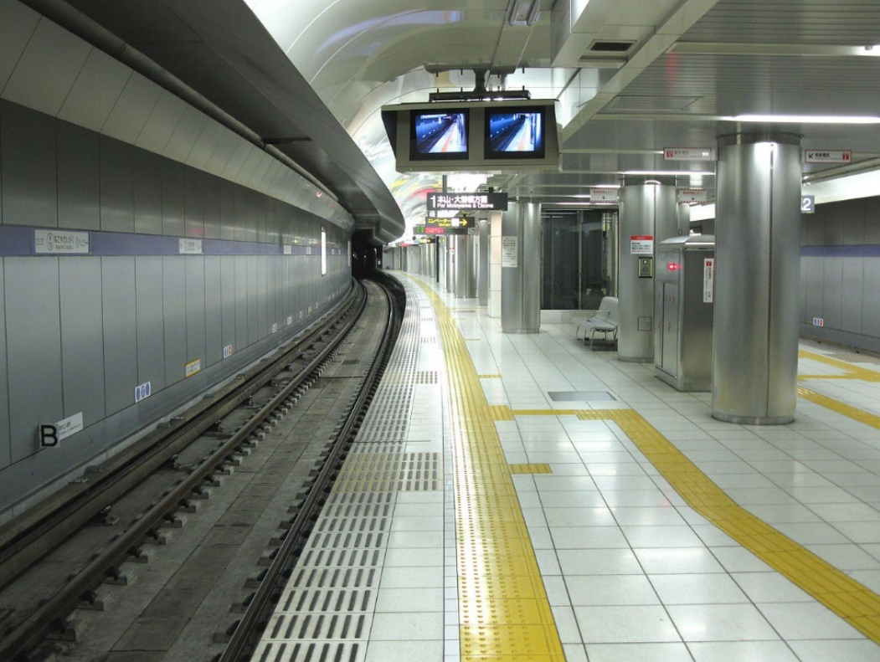

Figure : Tactile navigational aids on a train platform [4]

Crosswalks and intersections will often have acoustic crossing guides, providing both an audio indication of when it is safe to cross and a navigational “beacon” to the other side of the crosswalk [3]. It is important to note that any electronic aids, such as the one proposed in this project, should not interfere with the use of these pre-existing and pervasive tactile and audio navigational aids.

A more complex navigational technique employed by a subsection of the visually impaired is human echolocation. Echolocation is commonly associated with animals such as bats or dolphins, who emit high-pitched audio and listen for the echoes from the surroundings. These same techniques are employed by human echolocators. Echoes are created with a tongue click or cane tap [2] and acoustic properties of the echoes such as delay, frequency response and timing are combined with interaural level differences (the difference in audio level between the ears) and interaural timing differences (the difference in audio timing between the ears) to give a spatial understanding of the environment [2]. Use of echolocation has been correlated with higher levels of employment and overall income, indicating that better navigational ability may have significant real-life advantages [5].

The increased noise level and complexity of modern environments introduces new challenges for the vision impaired. The higher noise level in some city environments makes echolocation less effective or even impossible [6]. Audio cues such as “doors opening” or platform announcements on trains are important for the vision impaired, but additional audio sources such as speech or noise from electronic aids may negatively distract from these cues [1]. It is therefore important to ensure audio produced by the proposed device is predictable, on demand, and does not “drown out” other environmental cues.

### Existing Electronic Aids for the Vision Impaired

Ongoing advances in miniaturisation and power efficiency of electronics have created an influx of products and research in the field of electronic aids for the vision impaired. Many of the existing devices combine ultrasound sensors with haptic feedback to give warning of objects within 2-4m, such as the commercially available UltraCane, which takes the form of a traditional cane but includes ultrasound sensors in the handle and produces vibrations to indicate obstacles [7].

The field of research regarding electronic aids for the vision impaired is extremely active, and many of the techniques utilised find some overlap with the proposal in this project; none were found specifically utilising delay of multiple virtual localisation cues to indicate object distance, which indicates an area that may warrant further research.

In [8], a head-mounted RGB-D (image and depth) camera is utilised to identify walkable paths in the environment. Sounds are played in the user’s headphones to indicate obstacles blocking the walkable path, with different instruments (for example, piano or violin) mapped to different azimuth values for the obstacle. This paper provides several techniques for dealing with noisy RGB-D data, if required. Several of the paper’s authors extend their work in [9], wherein data from a head-mounted RGB-D sensor is fed into segmentation algorithms, and obstacles are classified (for example, “pedestrian” or “car”). These obstacles are mapped onto different sounds and played at different amplitudes to signify distance.

Another, somewhat simpler approach to obstacle detection and mapping is found in [10]. A laser-based depth sensor is utilised to produce 64x64 depth samples. Each sample is mapped to a unique sound based on distance from the sensor. The sound is convolved using the impulse response of a Head-Related Transfer Function as a function of the sample’s azimuth and elevation, producing binaural localisation cues (binaural localisation is discussed further in the next subsection). Each localisation cue is played in series starting at the top left of the 64x64 samples, and moving to the right, separated by 8ms. The efficacy of this system was tested by vision impaired users in navigational exercises.

Some research projects are based on the principles of echolocation, using electronic components to aid or enhance the effect. In [11], an speaker is used to produce “chirps” in the ultrasonic frequency range, and stereo microphones are used to listen for the echoes of these chirps from the environment, which they claim mimics bat echolocation. The signals received by these microphones are then filtered and shifted in frequency down to within the human hearing range and played into stereo earpieces, giving the impression of echolocation. It is important to distinguish such projects from this project – instead of utilising a sound source for depth information, this project utilised an infrared depth sensor.

As part of the due diligence performed in proposing this project a patent search was performed and no disqualifying patents were found.

### Binaural Localisation

There are many ways in which audio cues can be utilised to provide “localisation” to enable a person to understand their position in the world or the layout of the world around them. One such technique is binaural localisation – use of stereo sound (different audio in each ear) to produce the impression of sounds at a particular angle and / or distance from the listener [12], as shown in Figure 2. As described in the overview, one of the objectives of this project is to use sounds in stereo space to indicate the position of objects; such sounds are often referred to as “localisation pointers” or “localisation cues”.

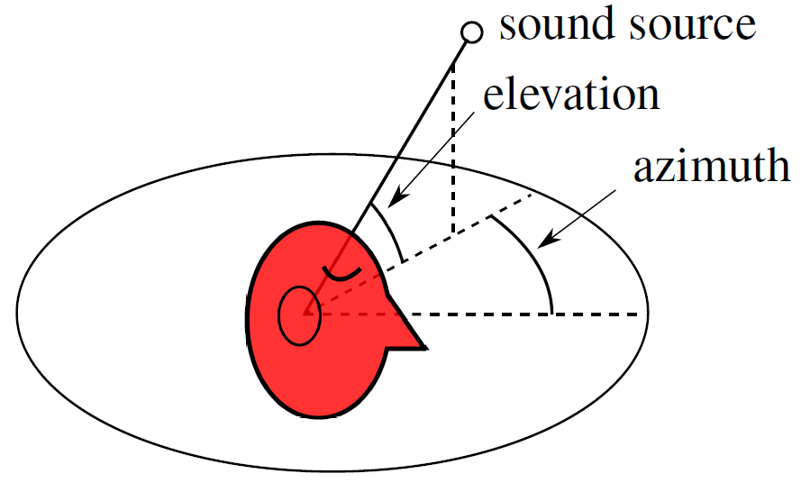

Figure : Head related coordinate system [12]

This technique is utilised in many forms of media, such as video games, movies, and specialised navigational tools to produce the impression of sound coming from specific locations [12]. It is often produced using headphones or hearing aids [13], with optional head-tracking to further improve the localisation of sounds as the user’s head moves. The existing research in this field allows a better understanding of what audio properties are desirable when designing localisation pointers in this project, and additionally how effectively we may expect binaural localisation techniques to perform.

In many methods used to produce binaural localisation, the audio is processed using Head Related Transfer Functions (HRTFs) [12]–[14]. These HRTFs simulate the head and ears’ physiology and are a function of the sound’s azimuth, elevation, and distance [15]. The sound signals are altered by HRTFs to reproduce phenomena such as interaural level differences and interaural timing differences. Many studies produce their own HRTFs by producing and recording sounds in a specialised setup [12]; more “generic” HRTFs are publicly available for download [15]. Being a transfer function, a HRTF can be applied to audio signals either by taking the signal into the frequency domain (using Fast Fourier Transform and its inverse to convert from the time domain to frequency and back), or by convoluting the signal with the HRTF’s impulse response in the time domain [15].

In [12], the binaural localisation performance of a number of different sounds (for example, claps, sine waves, and speech) were tested utilising a stereo microphone setup, and processed utilising HRTFs to simulate human auditory physiology such as the ears and head. Several parameters affecting the performance were tested and their localisation performances against an Additive Gaussian White Noise (AGWN) floor were quantified. The performance of some of these parameters are shown in Figure 3. With reference to the subplots beginning at the top left of the figure and working clockwise, the results can be summarised as such:

* Sounds between approximately 1kHz and 8kHz provided the best localisation performance (lowest localisation error);
* Increasing the spectral density of the sound by overlaying sounds of uniformly distributed frequency and random phase increases the localisation performance, with diminishing returns past 30 frequencies;
* Sounds such as claps or “plucks” exhibit vastly improved localisation performance over speech or single tones;
* The ideal length of a sample for localisation seems to be approximately 0.25 seconds in the presence of loud AWGN, but all sound lengths perform similarly without noise.

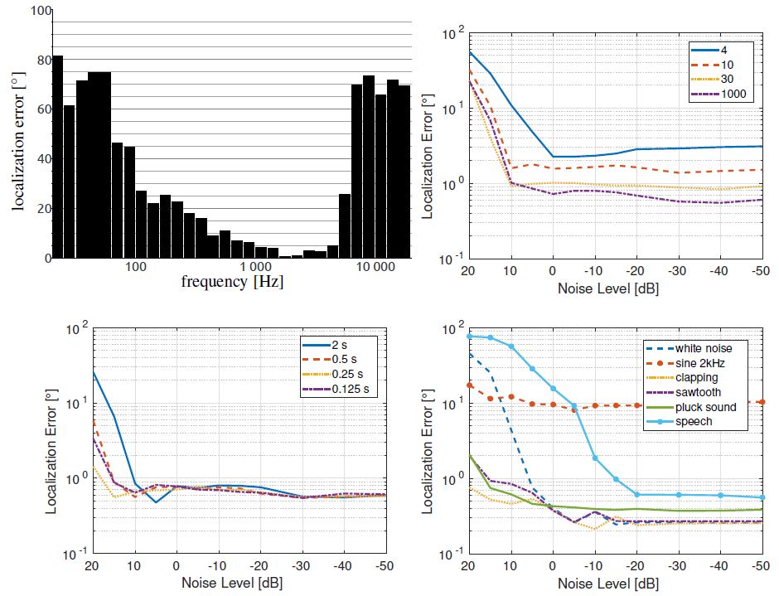

Figure : (Clockwise from top left) simulated localisation error of frequency choice, spectral density, sound types, and sound lengths [12]

It is important to note that localisation performance is only one factor to consider when selecting a sound or sounds to design localisation pointers. The sound(s) chosen must also be assessed for comfort and annoyance if they are to be utilised in a navigational device.

# Approach

## Base Case

A design for a wearable device for describing environments spatially using stereo sound is provided in the following section. The basic components of such a device are 1) a head-mounted depth sensor to provide spatial information based on the user’s environment; 2) a microprocessor to sample the depth data and produce sounds based on these samples; 3) stereo headphones to produce the audio; and 4) a button or input device to trigger the process.

A simplified base case, using this test data as an example, will now be presented. This represents the general implementation strategy of the project thus far from a high-level – more specific implementation details are presented in further sections.

An RGB-D camera produces several “streams” of data. The most important for this project’s purposes is the depth data, which is structured similarly to a camera photo, with individual pixels laid out on an *x* and *y* axis. This data signifies the “depth” of each pixel. A sample is given in Figure 4 below displaying frame captures of the same subject, with a true-colour “camera” photo on top, and a visual representation of the depth data below. In this chosen representation of the depth data, depth is mapped from white (close) to black (distant) for each pixel.

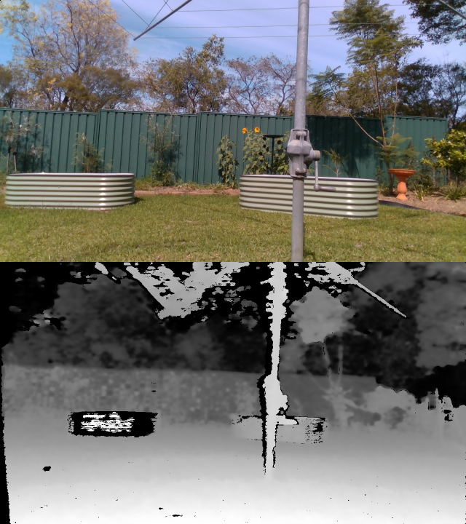

Figure : RealSense RGB frame (top) and RealSense depth frame (bottom)

The process of capture and sound playback is triggered by the user by depressing a hand-held button. This causes a depth sample to be captured. To sample and process the depth data:

* *n* samples are taken from the depth data, along the vertical centre (“the horizon”), and uniformly distributed along the horizontal axis;
* For each sample, an azimuth value will be calculated using trigonometry, and the depth value will be converted to distance using Pythagoras’s theorem;
* Samples with extreme values will be culled.

This process has been visualised using MATLAB in Figure 5 utilising raw depth data imported from a RealSense D435i, which shows a uniform placement of sample points on the depth data, and a top-down view of the “topology" formed by these samples. (Note that in the visualisation below, as well as in the raw data, the fence is indicated to be 30 meters from the camera, but this measurement is incorrect. The measurement for the clothesline is correct).

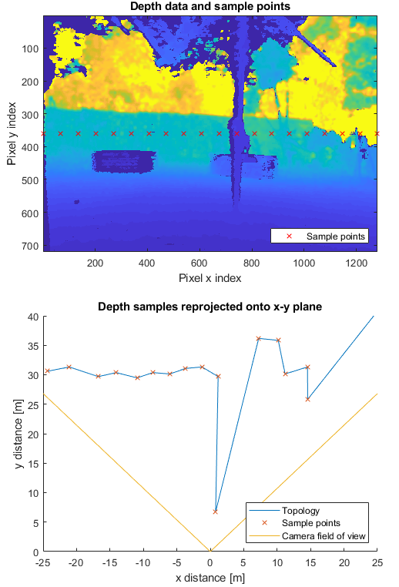

Figure : Visualisation of depth data sampling. Top: raw data and sample points. Bottom: reprojection of samples onto x-y plane

Next, one delayed and panned audio cue is played based for each of these samples (in the base case):

* Each cue will be delayed an amount of time proportional to the distance from the camera;
* Each cue is panned in the stereo soundscape based on its angle from the camera by adjusting the amplitude of the sample in each channel (left and right) using Constant Power Panning [16].

Note that the number of audio pointers as described above is quite high (20) – as implemented, the device only produces 3 audio pointers. This is not due to an implementation limit, but instead a user comfort consideration. These audio cues are multiplexed together into two audio streams and copied into the ALSA audio buffer in sections.

Taking the example scene above, the user should hear a sound cue slightly right of centre a few hundred milliseconds after depressing the button. This sound cue represents the object (clothesline) approximately 6 meters from the camera. A few seconds later, the user will hear two more cues, representing samples taken from the wall further back in the scene (although a cull value of approximately 10 or 15m might exclude these points). This should give an understanding that there is an object near to them, and the location in space of the object. Once the user understands the layout of the objects around them, they may begin moving and trigger more samples when required.

## Obstacle Detection Extension

To increase the usability of the device, an obstacle detection extension to the above base case has been implemented. After activating the device, it enters an “obstacle-detection” mode for a limited amount of time (10 seconds); during this time, changes to the environment such as new obstacles will be indicated to the user via unique sounds. These changes may be considered as new obstacles within the user’s immediate surroundings.

To produce this functionality, the depth information (or alternatively, obstacles which have been segmented out of the depth information) is classified into several classes based on their distance from the user. The following classifications have been implemented based on testing of the device:

|  |  |  |
| --- | --- | --- |
| **Distance** | **Classification** | **Notification** |
| <1m | Near | Objects in this range produce a high-priority audio notification |
| <2.5m | Mid | Objects in this range produce a low-priority audio notification |
| >2.5m | Far | No notification given |

Thereby, once the user has triggered the device, they are kept up to date on obstacles entering and exiting their immediate surroundings for a short period of time, reducing the amount of interaction required of the user (e.g. button presses). To reduce on the amount of information being provided to the user, the device only warns about obstacles directly in front of the user.

# Hardware Implementation

## Hardware Overview

The device described in this document uses the following consumer grade components:

* **Microprocessor: Raspberry Pi (RPi) 3 Model B+.** The RPi 3 B+ features a Cortex-A53 ARMv8 architecture system-on-chip running at 1.4GHz [17], which is roughly comparable to consumer-grade smartphones. For interoperability with the code libraries for the Intel RealSense sensor, the RPi is running Ubuntu MATE [18]. For brevity, this report will use the term “RPi” to refer to the microprocessor unit.
* **RGB-D sensor: Intel RealSense D435i**. The D435i depth camera operates at 640x480 pixels over USB2 (see the Device Firmware section below). The methodology described above does not require a large number of samples, and downsampling is employed. The D435i’s field of view is constrained to 87 degrees on the horizontal axis – this is covered in the limitations section. The device includes an accelerometer.
* **Headphones: Audio-Technica ATH-AD700X.** These headphones were chosen due to their availability, their frequency response in the 1kHz – 3kHz range, and their open-back design, which allows them to be used without blocking out environmental sounds.
* **User interface: Logitech R400 Presentation Remote.** This is a simple “presentation remote” device with multiple buttons which communicates with the RPi over the USB Human Interface Device protocol, natively supported by Ubuntu.
* **Power source: 10000mAh USB power bank.**

The RGB-D sensor is securely mounted to the top of the headphones, meaning that the camera’s field of view and horizon aligns with the user’s field of view. The RGB-D sensor is connected to the Raspberry Pi by a USB cable, and the headphones is connected to the Raspberry Pi using the stereo jack. The “clicker” is handheld and wireless.

During the process of implementing the project, the fourth major iteration of the Raspberry Pi was released. The RPi 4 features, among other changes, a drastically faster quad-core Cortex-A72 processor and two USB 3 ports [19] (previous iterations only feature USB 2). However, due to time constraints, as well as the relative immaturity of the device and possible concerns regarding software support [20], the decision was made to not attempt to migrate the project to the RPi 4.

## Device Firmware

The Intel RealSense D435i camera firmware was updated to 05.11.11.100. Later versions of the camera firmware allow for higher resolution depth frames (640x480, up from 480x270 in earlier versions), as well as the availability of depth and RGB (colour) images simultaneously over USB2 (earlier versions would only support depth frames over USB2) [21].

This firmware version unfortunately experiences significant issues with automatic exposure in full-light settings. There is a later version which resolves this (05.11.15.0), however this version introduces issues with depth frames not being fully filled when USB2.1 is utilised. A ticket has been filed with Intel in regards to this issue.

## Construction

The device construction is composed of three distinct units: the headphone / head mount, the processor / battery, and the pointer. The device, as worn by users, is shown in Figure 6.

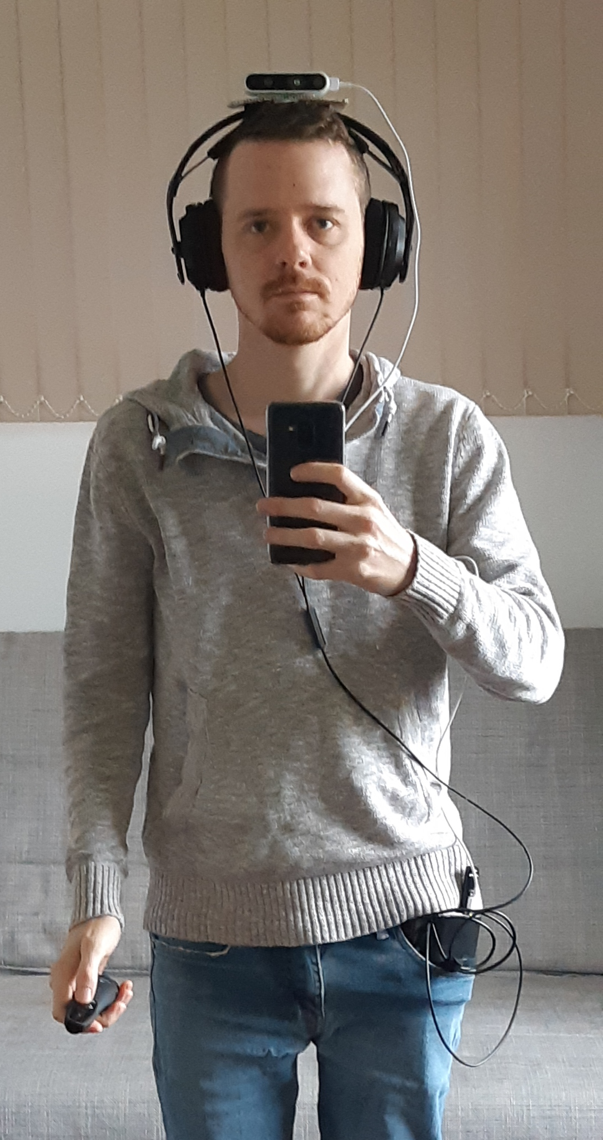

Figure : Device as worn by users

The camera is securely mounted to a piece of corflute using a ¼-inch UNC screw and plate, and the corflute is secured to the headphone head rest using Velcro tape fed through holes in the corflute, as in Figure 7. While rudimentary, this construction is stable and does not shift significantly during use.

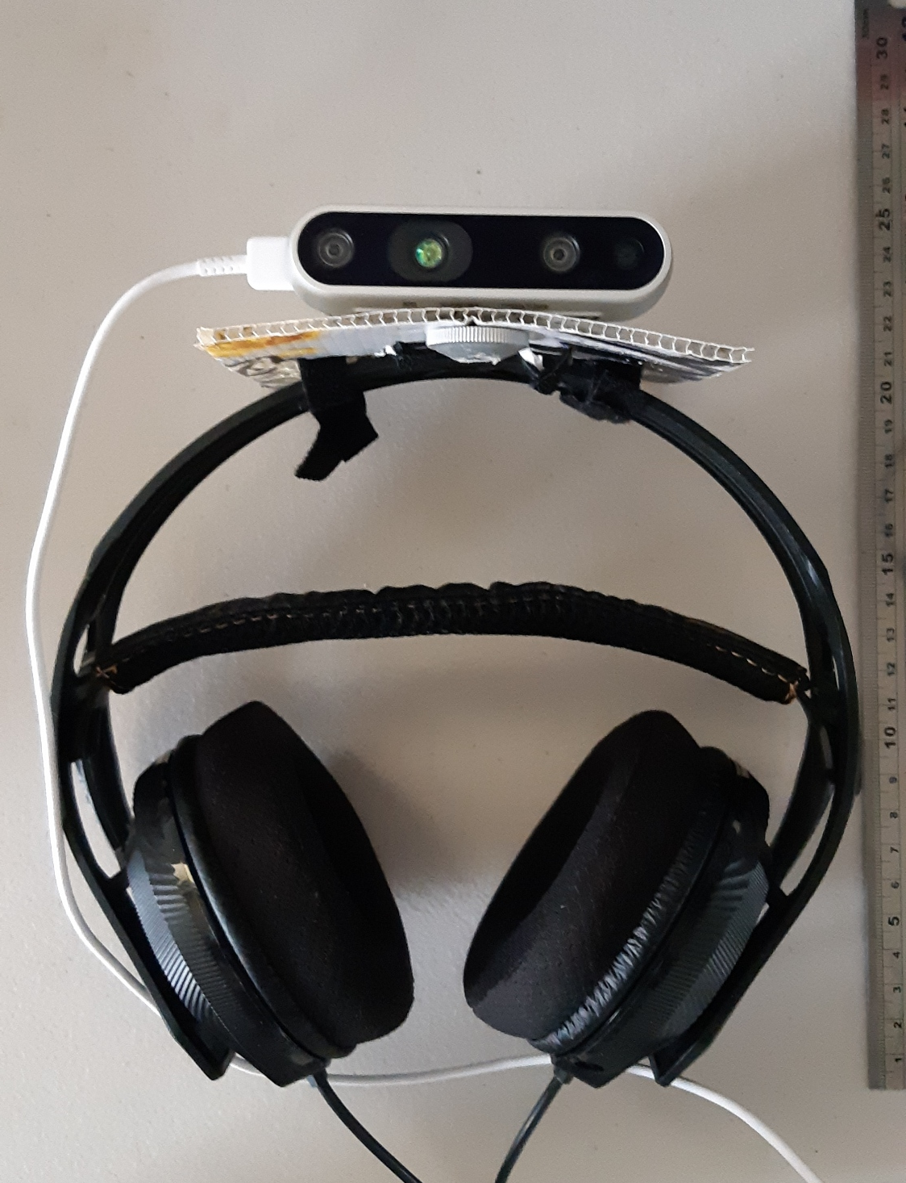

Figure : Headphones and camera mount

The stereo cable from the headphones and the USB cable from the depth camera plug in to the Raspberry Pi unit. The Raspberry Pi is encased in a protective enclosure. The unit is powered from a USB power bank via a micro-USB cable. The Raspberry Pi and power bank are held together using Velcro tape: a large strip is glued to the power bank and attaches to a small strip glued to the Raspberry Pi. MDF “stops” are also glued to the power bank to help stop the Raspberry Pi from sliding away from the power bank. This construction is shown in Figure 8.

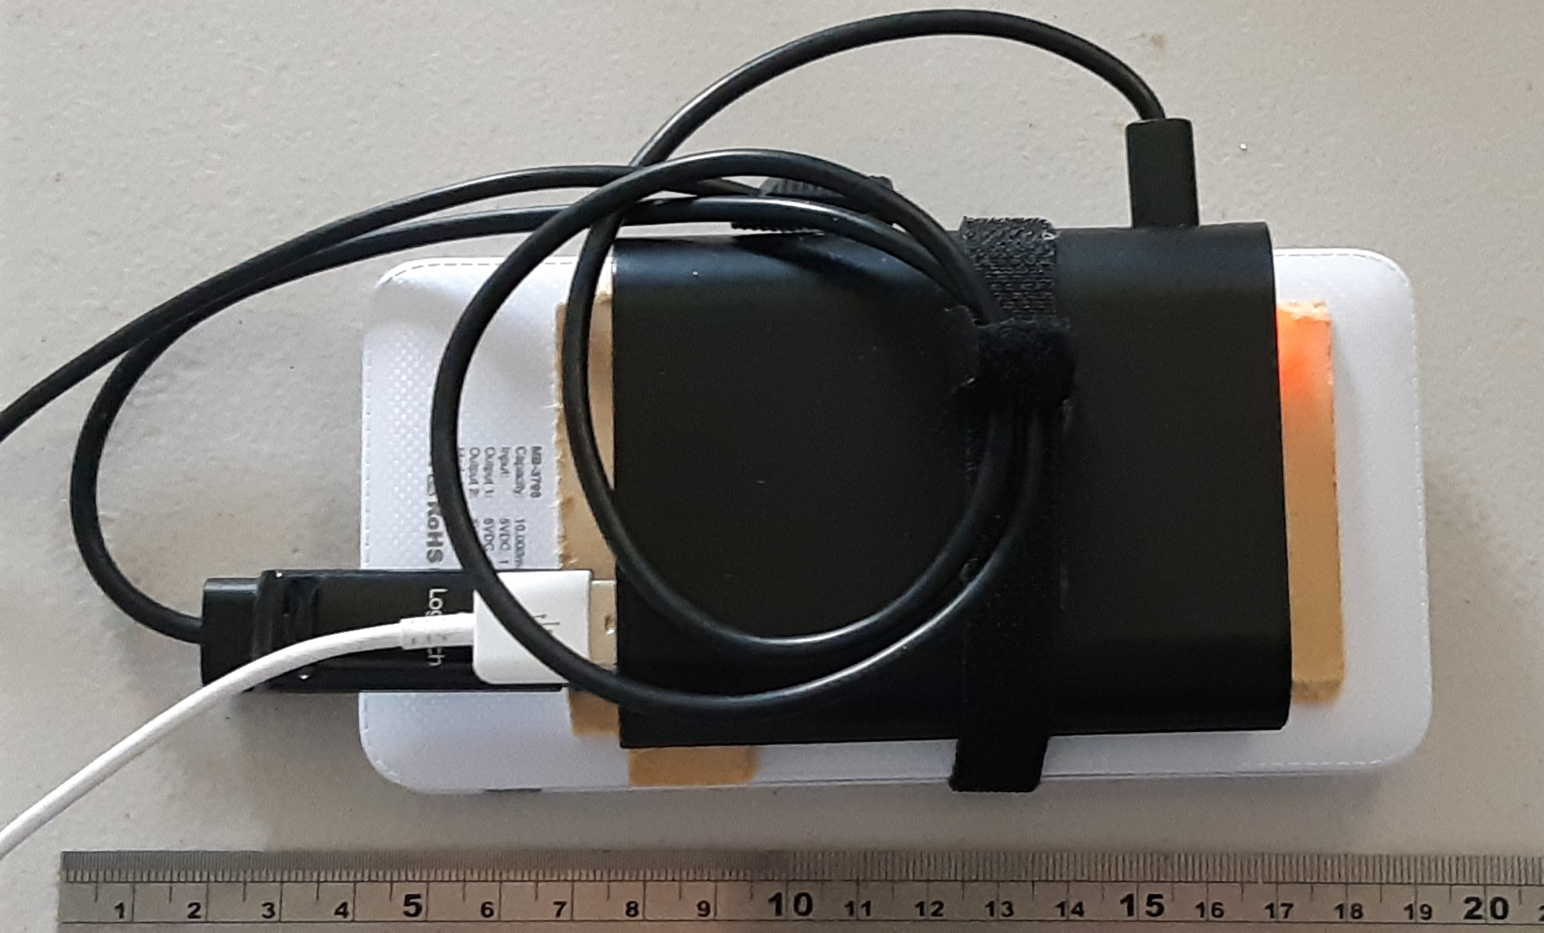

Figure : Raspberry Pi and power bank construction

The combined Raspberry Pi and power bank is relatively bulky but can fit in a large front pocket without stressing the cables, as demonstrated in Figure 6.

## Connectivity

Connectivity of the different components:

* **Intel RealSense camera:** connects to any USB 2.0 port on the Raspberry Pi using a USB A to USB C cable;
* **Headphones:** connect directly to the Raspberry Pi 3.5mm stereo port;
* **Power:** connects from port 2 on the power bank (specified as 5V / 2.5A) to the Raspberry Pi using a USB A to micro-USB cable;
* **Pointer:** the pointer transceiver plugs into any USB 2.0 port on the Raspberry Pi.

## Bill of Materials

A bill of materials for reproducing the hardware within this project is provided in Table 1. Note that the headphones were pre-existing and were not purchased for this project – an equivalent is provided but may cause performance differences.

|  |  |  |  |
| --- | --- | --- | --- |
| **Part** | **Model** | **Supplier** | **Cost** |
| System on chip | Raspberry Pi 3 B+ | RS Components | $37.78 |
| Depth camera | Intel RealSense D435i | Intel | $284.97[1] |
| USB pointer | Logitech R400 | Umart | $54.00 |
| Battery pack | Digitech 10,000mAh Dual USB Portable Power Bank White | Jaycar | $39.95 |
| Headphones | Audio-Technica ATH-AD500X | Audio-Technica | $189.00 |
| Enclosure | XC9002 Enclosure for Raspberry Pi | Jaycar | $5.95 |
| Total | | | **$611.02** |

Table : Bill of Materials

# Software Implementation

## Environment and Toolset Overview

Due to the existing support and documentation provided by the Intel RealSense project [18], as well as the ubiquity of available software packages, Ubuntu MATE 18.04.2 was chosen as the operating system for the Raspberry Pi device. Similarly, development was performed on an Intel x86-64 laptop running Ubuntu 18.04.2.

The code for this project is implemented in C++, utilising open-source C and C++ libraries as required. The CMake system was utilised to link packages and configure the build, and the make system was utilised to build the software. In this fashion, a single CMake configuration was produced and could be used to build the project for testing on both a laptop (Intel x86 architecture) and the Raspberry Pi (ARMv8 architecture).

When the device is booted, a startup script launches the application immediately, meaning that no user interaction should be required to set up the device once powered on.

## Architecture Overview

To produce an appropriate code architecture, the requirements and challenges of the device were considered, namely:

1. On-demand input based on a USB device;
2. Fast capture and processing of depth frames;
3. Low-latency sound without distortion or annoying artefacts such as “pops”;
4. Low power usage.

These requirements may conflict with one another. For example, to capture input, utility functions can be utilised which put the current process to “sleep” until an input is received, which has the added benefit of lowering power usage when compared to constant polling. However, while waiting for input, the audio subsystem (covered later in this section) must be kept updated with new audio samples.

Therefore, the program is split into three processing threads[2]. The main thread is responsible for initialising the device and processing input. The second thread is responsible for capturing and processing depth frames, and initialising audio “pointers” based on the depth frame data, as well as producing obstacle warning tones. The third thread manages the audio subsystem. All threads utilise sleep functions when not actively operating, which reduces CPU utilisation and lowers power usage. This is important since the device may be required to be on for long periods of time without user interaction.

A simplified overview of the code flow is given in Figure 9. This is expanded upon further in the section.

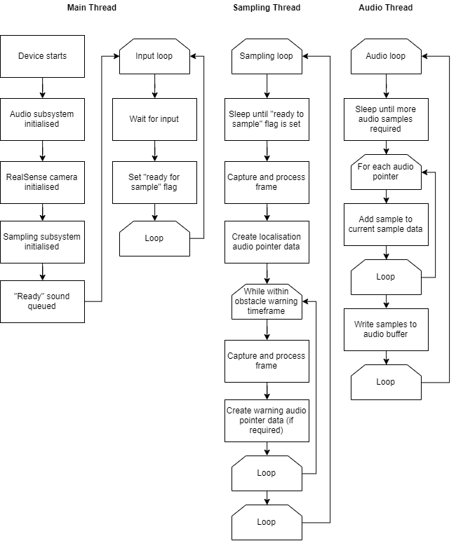

Figure : Code flow

## Input Handling

In the main input loop, the program will wait until it receives input from the USB pointer device before continuing to capture and process a depth frame. To achieve this, several options were considered:

* **Polling /dev/input IO streams:** while these streams are expected to contain all the information required to find input events and respond to them, parsing these streams can be complex and error prone.
* **Creating an X11 window and using X11 to register events:** X11 is a common windowing system in Unix and can provide mouse and keyboard events. However, starting an X11 window may introduce unnecessary complexity when it is only being used for input.

Eventually, the ncurses package was settled on as a solution. ncurses is a library which simplifies terminal handling in Unix-like systems and can be used to get mouse and keyboard events from a terminal application.

Input from the USB pointer is received simply by waiting on the getch() function. This will pause the main loop indefinitely until input is received. The result from the getch() function is tested to see if it is 339 (left click) or 338 (right click), at which time the program proceeds to capture and process a depth frame. Once input has been received, the ready_to_sample flag is set to true, which causes the sampling thread to begin its operation.

## Depth Capture, Sampling, and Processing

Once input has been received from the USB pointer, a flag is set for the sampling thread to capture a frame and process it for the purposes of creating audio pointers and obstacle warning sounds. At a high level, the following steps are taken:

* Once the ready_to_sample flag is set, the sample(true) function is called for the purposes of capturing depth data and creating localisation pointers;
* After a 2 second delay, the sample(false) function is called every 500 milliseconds to continually check for obstacles;
* After 10 seconds, the process awaits user input to begin again.

Note that the sample() function is used for both the process of creating audio localisation pointers and obstacle warning sounds – most of the depth capture and processing pipeline is shared between both tasks. The rest of this subsection of the report details the operation of the sample() function.

### Depth Capture

Depth frame capture is via the RealSense libraries. The depth frame capture is performed as below:

// Block program until frames arrive

rs2::frameset frames = p->wait_for_frames();

// Try to get a frame of a depth image

rs2::depth_frame depth = frames.get_depth_frame();

For performance reasons this frame is then decimated (reduced in resolution) from 640x480 pixels to 213x160 – a 3x decimation factor. This reduces the size of dataset by a factor of 9, vital for the current pipeline to be processed quickly on the Raspberry Pi.

The decimated depth frame is then converted to a 2-dimensional matrix of 32-bit floating point values representing the depth.

### Filtering

This depth information can be considered “raw” as it has not yet been subject to any post-processing steps. Depth frames captured from the RealSense device exhibit a number of imperfections including sensor noise, discontinuities due to specular surfaces and sources of infrared light, and “holes” in the data where the stereo sensors have not been able to correlate depth data at a certain point, and instead give back a null or zero value [22].

Therefore, once a depth frame is captured, it must have appropriate filtering applied to mitigate these issues. A filtering pipeline was created for the post-processing to:

1. Convert the raw data to OpenCV matrix form;
2. Perform spatial filtering to address noise and discontinuities; and,
3. Perform hole filling.

Several spatial filtering techniques were investigated for their appropriateness to address the issues of noise and discontinuities. Initially, a simple Gaussian kernel filter was proposed and implemented. A Gaussian filter has the advantages of being fast to perform due to its linearity, and does not produce “ringing” when applied (as seen when ideal low pass filters are used), due to the fact that a Gaussian function transformed into the frequency domain produces another Gaussian function [23]. However, a Gaussian filter does not allow for content-aware filtering, and therefore while it can suppress high-frequency content such as noise, it will also soften high-frequency components of the image such as edges. This leads to a loss of semantic meaning in the image.

A median filter was tested and was found to produce good results. Median filtering is applied in a “sliding window” fashion, where the value of each pixel is considered against all the pixels within an n-by-m window centred at that pixel. In the case of the median filter, the median value of within this window is applied to the pixel. Median filtering produces strong results against some forms of noise including impulse noise, while producing less smoothing of edges when compared to other low-pass filters [23]. It has the disadvantage of being non-linear, and therefore can be more computationally expensive to apply than linear filters, depending on the size of the image and the window utilised [23].

The results of median filtering as implemented with different window sizes are shown in Figure 10. The first image shows the “raw” depth frame from the camera, followed by median filters of window sizes from 3x3 up to 11x11 and a colour map has been applied. As the size of the window increases, the noise suppression performance increases without losing significant edge detail. However, increasing the window size causes a large performance reduction due to the increased computational complexity. For example, a 5x5 window size was found to take approximately 10ms to apply, whereas a 7x7 window size would take >50ms. As a compromise, a 5x5 window size has been selected. Note also that the median filter has begun to fill in small holes in the image with content from the surrounding area.

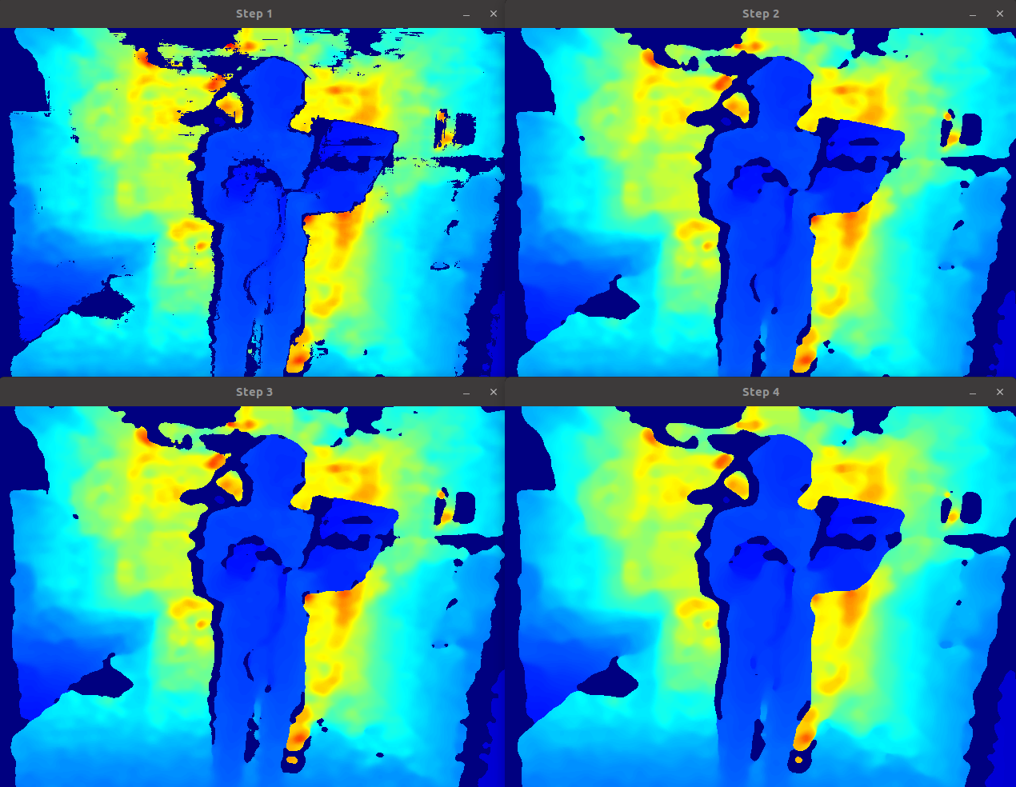

Figure : Median filters of increasing size. TL: Unprocessed; TR: 3x3; BL: 7x7; BR: 11x11.

Other filtering approaches were also considered. Bilateral filtering (sometimes known as “selective Gaussian filtering”) was tested, but still produced undesirable edge softening. Adaptive mean and adaptive median filters may be a good fit for this domain – more discussion is given in the Future Work section.

An unprocessed depth frame is also prone to “holes” in the data where shadowing or other effects have resulted in the RealSense camera being unable to provide a depth value for a pixel. The hole-filling filter mitigates this effect by filling all such pixels with a value from the neighbouring pixel with the largest depth value. While this process does not provide detail where there was previously no detail, it simplifies the process of using the image data since no “holes” of infinite depth exist in the image.

An example of this process is shown in Figure 11 – note the “shadowed” areas in the left image have been filled in with similar depth values from their surrounding areas in the right image. Also note that the left border of the filtered image still contains no valid data – this project’s code avoids sampling this section.

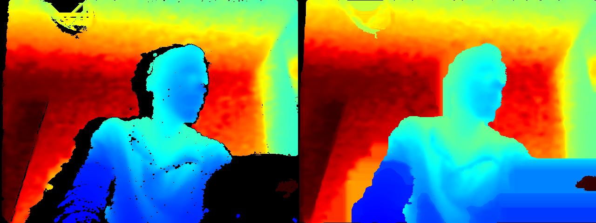

Figure : Unfiltered depth image (left) and hole-filling filtered image (right)

The RealSense package includes a hole-filling filter; however, it was seen to be beneficial for this project to perform hole-filling after the spatial filtering step. Therefore, once the distance matrix has been filtered, the image has a simple fill-from-left algorithm applied to fill any missing depth values with values from their immediate left. This is analogous to the RealSense hole-filling method. This method is shown below.

void hole_filling_filter(cv::Mat mat) {

for(int row = 0; row<mat.rows; row++) {

for (int col = 0; col<mat.cols; col++) {

float distance = mat.at<float>(row, col);

if (distance == 0.0 && col!=0) {

mat.at<float>(row, col) = mat.at<float>(row, col-1);

}

}

}

}

This processing is performed following the spatial filtering step. Figure 12 shows the whole filtering pipeline, with the unprocessed, median-filtered, and hole-filled depth frames shown with a colour image for reference. Note the “hole” in the image on the right of the hallway caused by sunlight reflecting off the specular wall surface which has been appropriately filled in with a combination of the median and hole-filling filters.

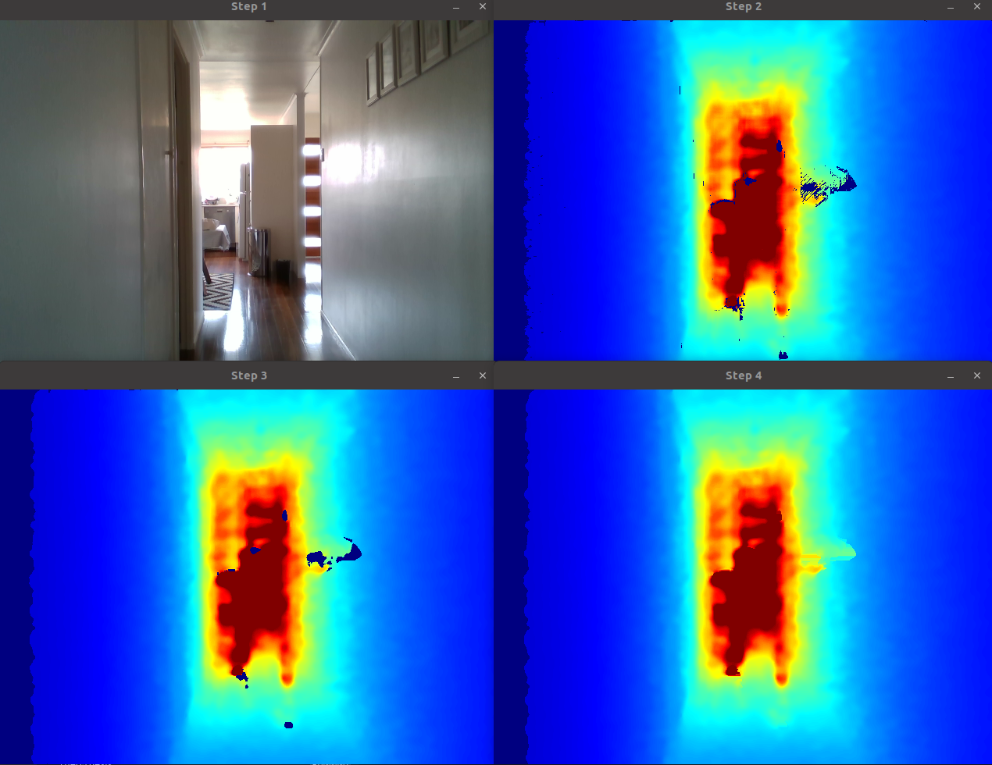

Figure : Filtering pipeline. TL: colour image; TR: unprocessed depth; BL: 5x5 median filter applied; BR: hole-filling filter applied.

## Depth Image Segmentation

To attempt to extract more semantic meaning out of the data, strategies for segmenting and classifying the depth image have been investigated and tested. The high-level goal for this process is to:

1. Provide a more reasonable value for depth checks for the left, centre, and right audio localisation pointers, instead of relying upon point samples;
2. Attempt to detect when obstacles have entered within certain “zones” of the user’s path. This may provide the basis for more sophisticated warning sounds to the user.’

### Segmentation Using Laplacian and Fill

Several segmentation approaches were attempted (see the Alternative Approaches subsection). Ultimately, a method utilising a Laplacian operation was implemented to break the scene down into regions representing similar depth, possibly being a single object or multiple connected objects.

While many different approaches were attempted, including more sophisticated use of Lapliacians such as the Marr-Hildreth method (combining a Laplacian operator with Gaussian blur and checking for zero crossings [23]), the method detailed below was found to be effective and computationally cheap:

1. Take the filtered distances array apply the Laplacian operator with a 3x3 kernel;
2. Perform a morphological dilation of the edges with a 3x3 kernel;
3. Find connected components and label;
4. Fill all instances of a connected component with the mean depth of that component.

In the first step, the Laplacian operator $(∇^{2})$ is applied. This effectively adds the result of two Sobel operators [24], where src is the source matrix and dst is the result:

$$dst=\frac{δ^{2}src}{δx^{2}}+\frac{δ^{2}src}{δy^{2}}$$

The resultant edges are tight to the edges of objects, and almost joined (note the small gaps at the end of each edge). The result is shown in Figure 13.

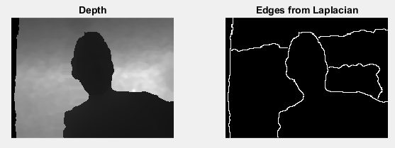

Figure : Depth image with Laplacian applied

The edges of the resultant are joined by applying a small (3x3) morphological dilation operation. Dilation is a simple morphological operation which “thickens” a binary image, and can be defined as:

$$A⊕B=\left\{z \right|{\left(\hat{B}\right)}_{z}∩A≠∅\}$$

where A is our binary image data, B is our “structuring element” (effectively a matrix of binary values), and ${\left(\hat{B}\right)}_{z}$ is the structuring element mirrored and translated to point z.

Next, each segment is given a unique label using the OpenCV connectedComponents() function. Finally, the depth values for each labelled component are summed, and the mean depth value calculated. This mean depth value is reapplied to each component, creating objects of constant depth. The result of this process is shown in Figure 14.

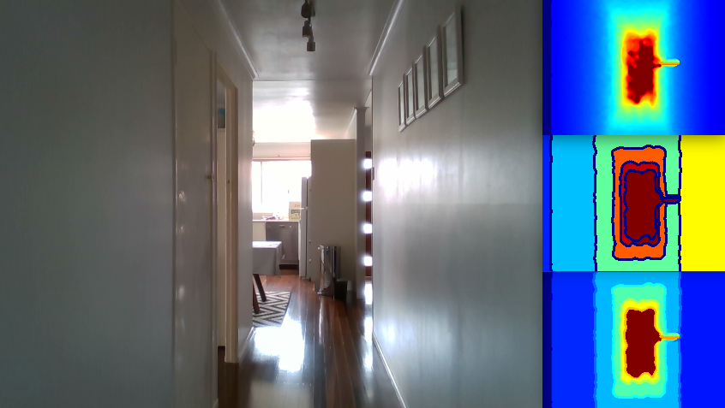

Figure : Result of Laplacian + fill process. Clockwise from left: RGB image (for reference); filtered depth; labelled components (colour arbitrary); and flood-filled components.

### Classification for Obstacle Warnings

For the warning system, 3 basic zones have been defined, representing distances closer than 1m to the user, distances between 1 and 2.5m, and distances beyond that. These distances were chosen based on a slow walking speed to represent something the user may be about to immediately run into (<1m), something the user may need to know will be an obstacle soon (2.5m), and otherwise where the user can continue to walk without obstacle.

The results from the Laplacian + fill process are thresholded at 1 and 2.5m of depth and then given to the get_overall_obstacle_class_from_thresholds(near, mid) function. An area in front of the observer (the centre-most 1/5th of the frame) is checked and if 30% of it is <1m, a classification result of 1 is given. If 30% of it is <1m or <2.5, a classification result of 2 is given. These classification results represent immediate and near obstacles respectively, while rejecting small results (<30% of the tested area) which may be spurious.

If the resultant classification is 1 or 2, an obstacle has been found. The following logic is checked:

* If it is too soon after the original triggering of the process, do nothing (this stops the warning from playing over top of the audio localisation “claps”)
* If a long enough time has passed since the last warning, or if the new classification is more urgent than the previous one, enqueue a warning sound.

Warning sounds are enqueued using the same sound playback approach as the audio localisation pointers, which is detailed in the Localisation Pointer Creation section below.

### Alternative Segmentation and Classification Approaches

Initially, a k-means approach was proposed. k-means classification considers the distance of each data point in the feature space to produce classifications – in the example of this device, initially a simple nearest neighbour implementation (k=1) using the depth of each point could be considered. In this fashion, the depth frame could be separated into a number (e.g. 3) of clusters of similar depth to produce a near, middle, and far depth. The depth frame could be further split by introducing the x and y co-ordinates as dimensions (k=3) to further cluster the data based on the position in the depth frame.

Unfortunately, this approach only attempts to produce clusters with the smallest “distance” between data points within each cluster and does not allow selection of the centre point of each cluster. With a scene with a large range of depth values (for example, an outdoors scene), clusters may include objects with a large disparity of depths, whereas this would not be the case for indoors scenes. These clusters are therefore difficult to map onto our desired classes as detailed earlier. An example with a higher number of clusters during initial experimentation is shown in Figure 15; as expected, this high number of clusters could not be simply mapped on top of our desired 3 classes. Finally, k-means clustering even with only one dimension (depth) proved to be possibly too slow to perform in real-time without severe downsampling of the image, requiring approximately 100ms to perform on an Intel i5 processor.

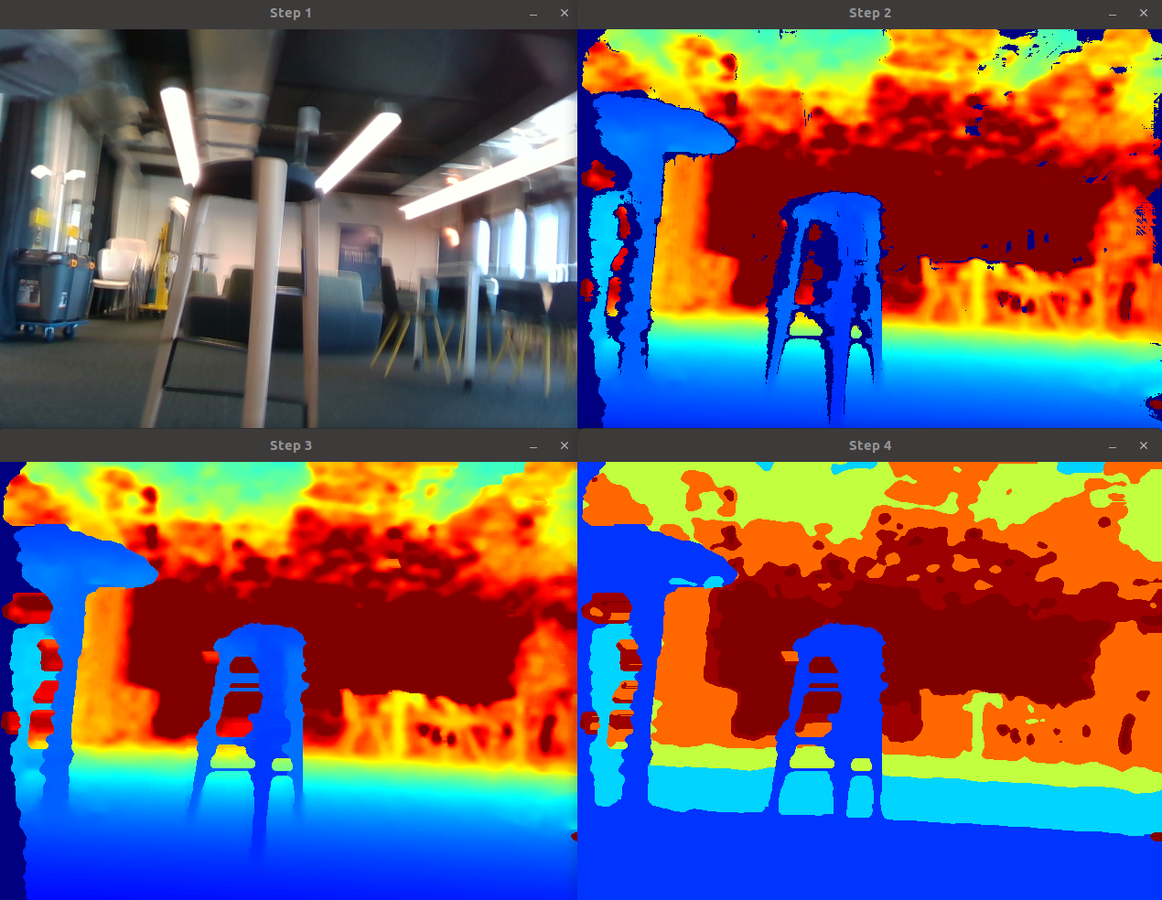

Figure : k-means clustered scene. TL: colour; TR: raw depth; BL: filtered depth; BR: k-means clustered depth

A value thresholding approach was also tested to provide our classes. This approach is simple and has the advantage of being extremely quick to perform but produces limited semantic meaning. The depth image is classified pixel-by-pixel, checking the depth of each pixel versus our three thresholds and labelled based on whether it falls in the near, mid, or far planes.

To exaggerate obstacles in the near plane, these values are dilated with a tall structuring element (e.g. 2x50). The output of this operation effectively thickens or dilates the input data by the size of the structuring element; hence by using a tall structuring element, we can exaggerate the height of obstacles.

The results of this process can be seen in Figure 16 and Figure 17. In both examples, note that the colour image has a different field of view to the depth (for example, in the first figure, a table is visible on the right of the depth which is not visible in the colour image). In Figure 16, the chair and table closest to the user have been effectively classified. In Figure 17, the passageway has been split into near, mid, and far depths. Note also the adjoining passageway on the right of the image (only slightly visible in the colour image) is classified into the “mid” plane, which may be useful in presenting to the user that it can be navigated.

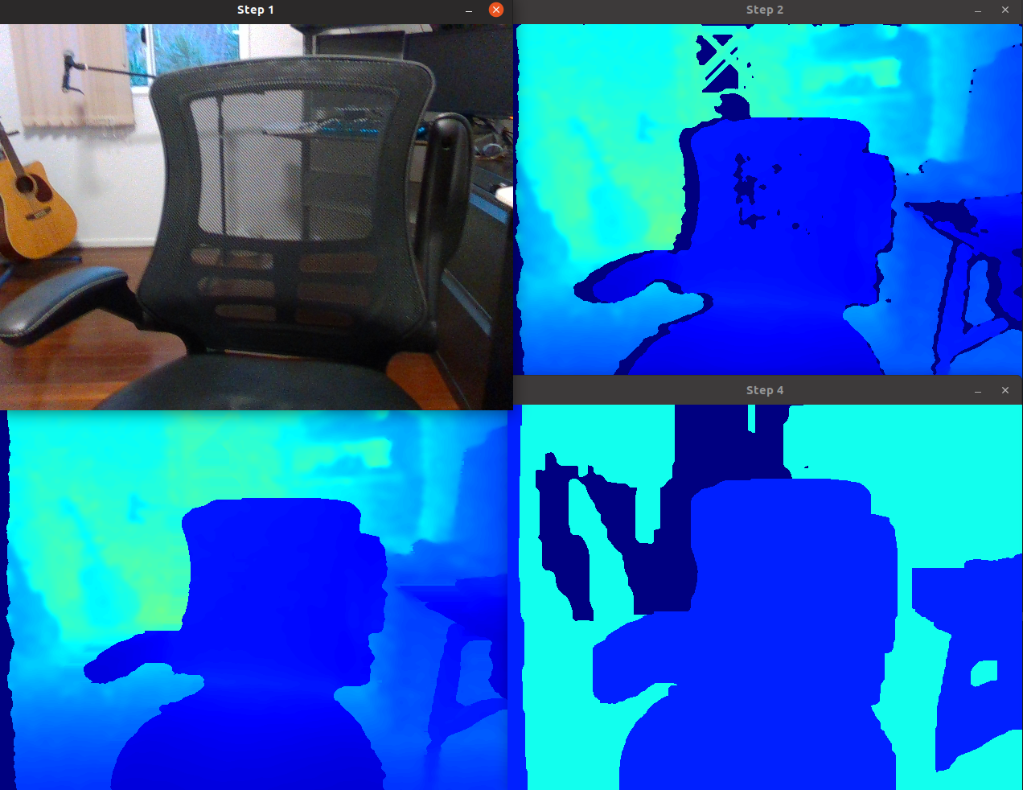

Figure : Thresholding and dilation of obstacle. TL: colour; TR: raw depth; BL: filtered depth; BR: thresholded and dilated depth

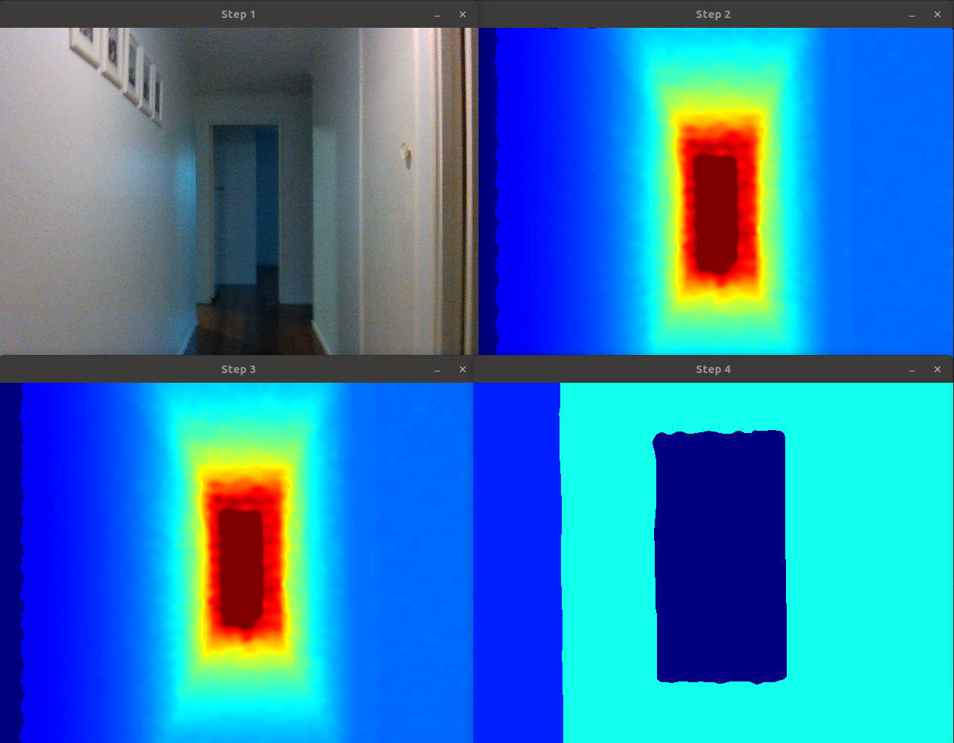

Figure : Thresholding and dilation of passage. TL: colour; TR: raw depth; BL: filtered depth; BR: thresholded and dilated depth

While this method was ultimately discarded due to success with the Laplacian method detailed earlier, it did prove to be performant and reasonable effective for obstacle classification for the warning system; however, it is too simplistic to be used with the audio localisation pointer system.

## Localisation Pointer Creation

As the purpose of the device is to produce audio localisation pointers based on depth data, but the depth capture process and the audio playback process are on two separate threads, a data structure to give the audio playback thread all of the information required regarding the panning and delay of each localisation pointer was created:

struct audio_pointer

{

float left_amount;

float right_amount;

uint delayms;

uint sample_index;

};

This section describes the translation of depth data to produce these audio pointer structures, and the purpose of each parameter.

Once the depth frame is filtered, point samples are taken at different azimuths along the horizon (i.e. halfway down the frame vertically) to produce audio localisation pointers. Note that this process will be the subject of much future work: the technique presented here is merely foundational. Currently, the depths at azimuths [-32°, 0°, 32°] are taken, although the code supports an arbitrary number of pointers. These azimuths have been selected as they are close to the full horizontal range of the camera, but do not use the edges of the depth frame which can be subject to shadowing and invalid data.

To find the pixel location for a given azimuth, the field of view (FOV) metadata from the sensor is utilised. The x pixel location is taken as:

int x = width * (theta + fovwidth / 2) / fovwidth;

Here, width is the width (in pixels) of the frame, theta is the azimuth where 0 degrees indicates straight ahead of the subject, and fovwidth is the total width (in degrees) of the frame taken from the sensor metadata. This effectively takes a sample proportionally along the horizon depending on the sample location azimuth.

The y pixel location is simpler, taken from the vertical midpoint:

int y = height / 2;

Finally, the processed depth frame is sampled at the given point to determine the distance at that point from the observer, and a delay is assigned to the audio pointer which is proportional to the distance:

audio_pointers[i].delayms = distances.at<float>(y, x) * METERS_TO_DELAY_MS;

This distance is scaled by the constant METERS_TO_DELAY_MS, which converts the distance of the point to a millisecond delay. This is currently configured to 250 $\left[\frac{ms}{m}\right]$– each meter of distance from the camera translates to 250 milliseconds of audio delay.

To “position” the audio pointer in stereo – i.e., to provide the user an impression of what angle the sound representing this audio pointer is coming from relative to their head’s orientation – a technique known as constant power panning is used. To give an impression of a sound’s position, the volume of the left and right channels (corresponding with the left and right ears) are altered for a given audio pointer based on its azimuth.

A naïve panning approach might involve linearly altering the volume in the left and right channels for an audio pointer depending on their position. However, for a sound directly in front of the user (azimuth of 0), the left and channels would both have a volume of 0.5. Due to possible phase differences between the two channels, the combination of the two signals would not combine to give the impression of a volume of 1, but instead would experience a power loss of 3dB [16].

Constant power panning accounts for the volume loss due to phase difference between the two channels by boosting sounds that are placed in the centre. To do so, we utilise trigonometric rules to give volume curves which give a left channel volume of 1 when it is positioned directly to the left (-90°), a volume of 0 when positioned directly to the right (90°), and a volume of $\frac{\sqrt{2}}{2}$ when directly in the middle [16]. To produce these volume curves, the following equations are used:

$$A_{left}=\frac{\sqrt{2}}{2}\left(\cos\left(\frac{θ}{2}\right)-\sin\left(\frac{θ}{2}\right)\right)$$

$$A_{right}=\frac{\sqrt{2}}{2}\left(\cos\left(\frac{θ}{2}\right)-\sin\left(\frac{θ}{2}\right)\right)$$

When visualised, this gives the volume curves given in Figure 18.

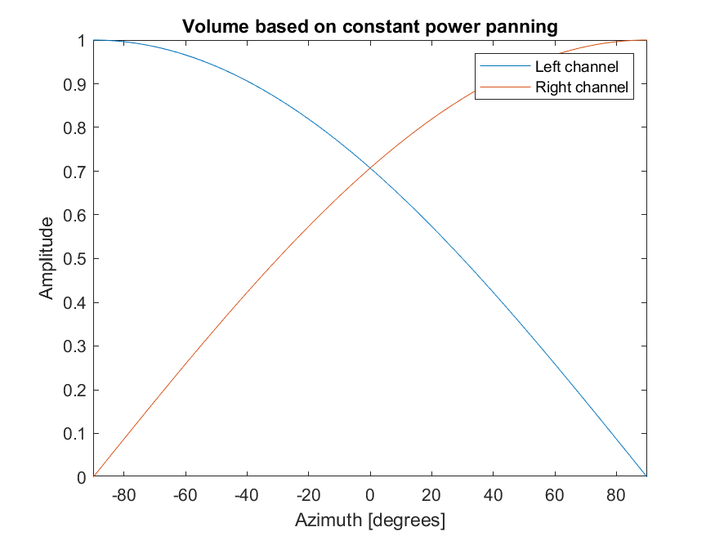

Figure : Volume based on constant power panning

These values are generated based on our azimuth values and assigned to the audio pointer variables:

audio_pointers[i].left_amount = 0.707107f * (cos(theta_rads/2) - sin(theta_rads/2));

audio_pointers[i].right_amount = 0.707107f * (cos(theta_rads/2) + sin(theta_rads/2));

The concept as proposed was to provide accurate azimuths to the listener to give a “natural” understanding of where the depth-tested objects are in space. However, with the approach detailed above, the separation of the left, centre, and right audio was not enough to easily distinguish one from another. In the final implementation, the azimuth angle is exaggerated by a factor of 2.

The audio pointers produced from the depth frame are now fully initialised and ready to be consumed by the audio subsystem. The next section will cover the process of producing sounds based on these audio pointers.

## Sound Output

The sound output has been implemented by interfacing with the Advanced Linux Sound Architecture (ALSA) software in Linux. ALSA is a low-level Linux audio subsystem with support for many audio devices, including output from the Raspberry Pi. The ALSA C libraries have been utilised for this project.

The role of the audio subsystem is to consume the audio pointer data and play back audio for each of the audio pointers, delayed and panned in stereo by the amounts given in the audio pointer struct, as covered in the previous section.

### Audio Data

During the literature review, it was found that sounds of duration 0.25sec with frequency content between 1kHz and 8kHz performed well as localisation pointers [12]. A “clap” sound was also found to provide good localisation performance in the presence of noise. Based on this, a clap was recorded using a Shure SM58 microphone and exported as 16-bit, 44.1kHz PCM audio. A waveform analysis of the audio is shown in Figure 19. It can be seen that the audio data contains frequency content up to 10kHz.

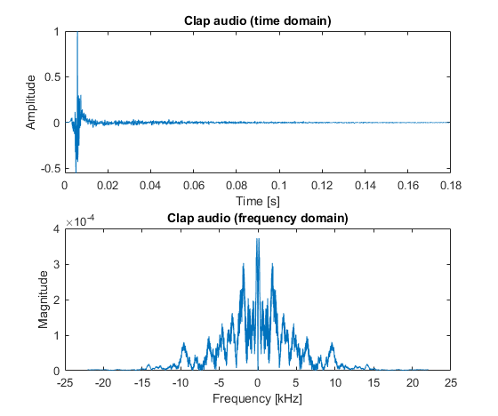

Figure : Clap waveform analysis

For the obstacle warning sounds, initially artificial beeps were used. However, in testing, these beeps proved annoying to the user. These beeps were replaced with piano notes recorded from the Ableton digital audio workstation program: a middle C note played for near obstacles, C + G notes played for immediate obstacles, and a C major chord played to signal the obstacle detection phase is finished.

On launch of the program, these files are read into an array of arrays of 16-bit signed integers (int16_t). The first 44 bits are skipped, as these constitute the header of a .wav file and do not contain audio data.

### Audio Parameters and ALSA Setup

ALSA allows granular configuration of audio parameters when initialising the libraries from code, and parameters must therefore be selected carefully for the intended usage.

|  |  |  |
| --- | --- | --- |
| **Parameter** | **Value** | **Rationale** |
| Sample rate | 44100Hz | Within the literature review it was shown that frequencies up to approximately 8kHz are useful for binaural localisation performance [12]. By the Nyquist-Shannon sampling theorem [25], this would require a sampling rate of 16kHz to represent, meaning that the commonly-supported 22kHz rate would fulfil this requirement.  The value of 44.1kHz was chosen initially because it would allow full reproduction of the commonly-accepted human hearing range, 20Hz-20kHz [26]; however, this represents a 2x increase in the amount of samples needed to be delivered to ALSA over 22kHz. If latency becomes an issue, this rate could be lowered. |
| Sample bit depth | 16bit | Higher audio bit depths produce a higher theoretical maximum signal-to-noise levels. 16bit is common for PCM audio applications such as CD audio [27]. |
| Endianness | Little | The sample endianness determines whether each 16bit sample begins with the least-significant bit (little endian) or the most-significant bit (big endian). Intel and AMD x86 processors are little-endian, whereas ARM processors can be configured either way; by selecting little-endian samples, testing on both an x86 laptop and the Raspberry Pi is possible. |
| Channels | 2 | Stereo headphones use two discrete audio channels (left and right). |
| Buffer size | 1024 frames | Audio is delivered to ALSA in “frames”, where each frame contains samples for each channel. The higher this number, the more frames must be delivered to ALSA at a time, increasing latency but decreasing overhead. 1024 frames at 44.1kHz represents approximately 23ms of audio. |
| Frame format | Interleaved | To produce a stereo signal, samples for each channel are interleaved before being passed to ALSA. This is explained further later in the section. |

### ALSA Usage

Before demonstrating the device’s real-time audio setup, first an explanation of ALSA usage in the configuration highlighted above is given. Note that ALSA is a large and flexible software package – presented here is only one potential usage.

As given above, ALSA is configured to be delivered buffers of 1024 samples, with left and right samples interleaved into a 32-bit “frame”. This sample count is multiplied by the number of channels, meaning that a total number of 2048 16-bit, 44.1kHz samples must be delivered to ALSA at a time. The structure of such a buffer can be visualised as below, where $x_{n,left}$ is the nth 16-bit sample for the left channel, and $x_{n,right}$ is the nth sample for the right channel:

$$\left[ x_{0,left}, x_{0,right}, x_{1,left}, x_{1,right}, …, x_{1023,left}, x_{1023,right} \right]$$

Therefore, the ALSA audio buffer is declared as an array of 16-bit signed integers (int_16t) of length 2048. This is delivered utilising the interleaved write function, as such:

snd_pcm_writei(pcm_handle, alsa_buffer, alsa_frames_length)

(Note that by convention, the ALSA frames length parameter is related to the sample rate and not the number of channels. In this usage, the number of frames is therefore 1024).

In the default configuration, the ALSA subsystem will accept a large amount of data with repeated calls to the write function. This causes a large “queue” of samples to be produced in ALSA to be played. For example, it is possible to queue up several seconds worth of samples with a for loop in our code in a very short amount of processing time. No new sounds can be played until the sounds represented by the queued samples are first played, meaning that any new audio samples would have their playback delayed by several seconds in this example.

This is not appropriate for “real-time” audio systems such as required by this device. By pressing the handhold control button, the user may request a new audio representation of their environment at any time, meaning that sounds should be able to be played on demand with an unnoticeable delay. Therefore, careful management of the ALSA sample queue is required so that it does not grow large enough to delay new sounds. Conversely, if the ALSA queue becomes empty, a “buffer underrun” occurs, and the ALSA handle shuts down until it is re-initialised.

ALSA provides several utility functions to assist with managing the queue length. Of note is the snd_pcm_delay(pcm_handle, &delayp) function, which sets delayp to the number of frames in the ALSA processing queue (the frame “delay”).

This overview of functionality has been given to provide context to the general challenges of producing real-time audio with ALSA. The next section will demonstrate how the specific requirements of the device are implemented within this framework.

### Audio Workflow

Based on the requirements highlighted in the previous section to provide error-free, low-latency audio using the ALSA library, a workflow for consuming the audio pointer data created in the sampling step and producing delayed audio localisation sounds is now presented. The code in this section runs on its own thread, separate to the main loop, and shares only the audio pointer data. The thread itself contains one loop, which runs indefinitely to keep ALSA supplied with samples.

Firstly, the ALSA subsystem is queried to determine the overall sample delay using the ALSA function:

snd_pcm_delay(pcm_handle, &delayp);

The output parameter delayp gives the delay, in frames, in the ALSA system. This frame delay is converted into a time delay by dividing by our audio sample rate. If this time delay is more than 100ms, the thread sleeps using the usleep function in 50ms increments until the time delay is reduced to less than 100ms. This puts an upper limit on the latency of queued samples. The maximum audio delay is configurable – too high a value and the latency of the system increases, but too low a value and the system risks buffer underruns (the ALSA system runs out of samples to play back while we are queuing up new samples).

Once the ALSA system is ready for more samples, the maximum number of frames the system is ready to accept is tested utilising the following ALSA function:

frames_to_deliver = snd_pcm_avail_update(pcm_handle)

As described above, the number of samples we need to deliver is double the number of frames (one sample per channel). To reduce the size of the buffer and the overall latency, the frame count is capped at 1024, meaning we deliver approximately 23ms to ALSA at a time.

Samples are generated a frame at a time (i.e. one sample for the left and right channels) based on the audio pointer data captured earlier. This process is visualised in Figure 20.

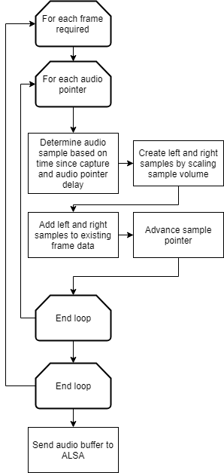

Figure : Audio buffer generation

Creation of the audio buffer utilises a “sample pointer”. This sample pointer begins at 0 when a depth image is captured and is advanced by one for each audio frame. Additionally, the sound system allows for an arbitrary number of different sound waveforms – this allows us flexibility in assigning different kinds of sounds for different events if required in the future. The startup and obstacle sounds also utilise this feature.

For each audio pointer, we must determine how to produce audio for a given frame based on the sample pointer and the audio pointer delay. The audio pointer delay is converted from milliseconds to a sample count by multiplying by 44.1 (our sample count in kHz). Then, this delay is subtracted from the sample pointer. If the resultant index is greater than 0, and less than the length of our “clap” audio array, the given sample from the audio array is used. The sound_index parameter selects which sound to play. The get_sample function below demonstrates this process:

int16_t get_sample(int samplei, uint delayms, sound_index)

{

int16_t sample = 0;

int samplei_delayed = samplei - get_delay_in_samples(delayms);

if (samplei_delayed >= 0 && samplei_delayed < sound_array_length)

sample = sounds_array[sound_index][samplei_delayed];

return sample;

}

The result of this function is a 16-bit audio sample based on the amount of time elapsed since the USB pointer was clicked, and the delay of that audio pointer. The volume of this sample is then scaled based on the left and right volume amounts we calculated from the depth capture process, and added to the existing frame data:

int16_t this_sample16_left = get_sample(samplei, sample_delayms, sound_index);

sample16_left += this_sample16_left * audio_pointers[pointeri].left_amount;

int16_t this_sample16_right = get_sample(samplei, sample_delayms, sound_index);

sample16_right += this_sample16_right * audio_pointers[pointeri].right_amount;

We have now generated $x_{n,left}$ and $x_{n,right}$. These are written into our ALSA buffer and the sample pointer is advanced:

alsa_buffer[i] = sample16_left;

alsa_buffer[i + 1] = sample16_right;

samplei++;

Finally, once all the required frames have been generated, the buffer is written to the ALSA device, causing it to be queued for playback:

snd_pcm_writei(pcm_handle, alsa_buffer, alsa_frames_length);

### Startup Sound

Because no graphical user interface can be shown in normal use, it was found to be difficult to understand when the device has completed its startup process and is ready to use. To aid this, an audio sample stating “the device is ready to use” was recorded, and this sound is played once the code has finished initialising all the subsystems. This sound is played through the same audio subsystem as described above.

## Other Usage Considerations

### Visualisation

While not utilised in normal usage, visualisation of the depth frame can assist in troubleshooting and fine-tuning the operation and parameters of the device. To provide a visualisation of the depth data, the OpenCV framework was utilised. A flexible visualisation system was produced to allow the code to display up to 4 tiled windows, depending on the application. Depth images are automatically colourised with a custom colour map to produce a stable colour mapping based on the device’s usable range. This visualisation approach can be seen throughout this report.

### Power Usage and Management

The power usage of the prototype device on a 10,000mAh battery (as of Semester 1 progress) was shown to be problematic and only produce approximately 90 minutes of usage time. While not the core focus of this project, the power usage makes a large difference in the overall usability of the device. There are many possible factors contributing to the higher than expected power usage of the device, including:

* **Power draw from the Intel RealSense unit while idle:** even while the device is awaiting input from the user, the Intel RealSense device has its IR emitter switched on, and remains active.
* **Power draw from Raspberry Pi subcomponents:** any Raspberry Pi hardware components not related to the project functionality such as Wi-Fi should be disabled;
* **Power draw from USB presenter:** the wireless dongle for the Logitech R400 presenter constantly operates while the unit is on;
* **Excess CPU usage in the device code:** while the project code is running, it is constantly updating the ALSA audio feed, as well as providing processing functionality for the Intel RealSense camera. The project code includes low-power sleep commands where appropriate (for example, when waiting to provide ALSA with more sound samples).
* **Excess CPU usage in Ubuntu processes:** similarly, it is possible that background processes in Ubuntu are causing CPU usage.

To better understand the power usage of the device, testing of the device’s power draw, and the power draw of USB-connected peripherals, was performed utilising a USB voltmeter / ammeter. The testing process is as follows:

* The full power draw of the device was measured at the Raspberry Pi’s USB port;
* The power draw of the camera and pointer receiver were individually tested during use at their USB ports;
* The power draw of device Wi-Fi was measured by switching the Wi-Fi on and off and measuring the difference in power draw.

The device was tested both while this project’s code was being run and while only the operating system was running, and the results can be seen in Figure 21 below. Note that the first column represents the power draw of the Raspberry Pi, with the measured power draws of the peripherals subtracted.

Figure : Device power profiling

The total power draw when running is approximately 3.5W / 0.9A, which should give a much longer runtime than currently experienced on the 10Ah pack. It is possible that there are large, transitory current draws from the device which are not being properly measured through the ammeter.

To attempt to extend the longevity of the battery a low-power mode was introduced to the device. This mode is triggered by the user pressing the 3rd button on the remote twice in a row. Once this mode is triggered, the sampling thread calls the stop() function on the RealSense pipeline and plays a sound to let the user know the device is in low power mode. The sampling pipeline also reduces its loop sleep time from 10ms to 100ms.

The effect of the low-power mode was quantified through profiling of the CPU, and through power measurements. A summary of the results is given in Table 2. Note that CPU usage ranges from 0% to 400%, representing use of the 4 Raspberry Pi cores.

|  |  |  |
| --- | --- | --- |
| **State** | **Current draw [mA]** | **CPU usage [%]** |
| Ubuntu, project not running | 500 | 2-5% |
| Project idle in normal mode | 850 | 185% |
| Project in obstacle mode | 900 | 285% |
| Project in low-power mode | 530 | 20% |

Table : Power profiling results

The difference between current draw of the device with and without low-power mode is significant. The only significant change to the device state is the status of the RealSense pipeline, showing that in situations where power usage is a major concern, careful management of the RealSense device is paramount. However, it is fully understood that the RealSense device draws more transitory current while starting the pipeline, which may begin to outweigh the power gains from low-power mode if switched on and off repeatedly. Other power saving methods for the RealSense device were investigated such as toggling the IR emitter but none were satisfactorily implemented.

# Evaluation

## Navigational and Spatial Awareness Performance

The mechanism of communicating distance of objects from the user using delay of the sound is effective and intuitive. The communication of the azimuth of the localisation pointers from the user is less successful: since the pointer azimuths are set at -32, 0, and 32 degrees (which is close to the maximum available from the field of view of the camera), the angle of separation between each is small, and the method of constant power panning does not produce a large perception of separation between them, meaning that it is easy to confuse the left and right pointers for the centre pointer. For this reason, the angle of separation in stereo was artificially increased to pan the left and right audio pointers further to the left and right respectively.

The performance of the device as a navigational and spatial awareness tool was tested in two environments: hallways, and open spaces with walls (e.g. a garage). Its effectiveness at this stage is rudimentary but shows signs of promise. In a hallway, the user’s orientation and positioning relative to the walls is discernible from the delay in the left and right audio pointers, and the audio pointer in the centre’s longer delay communicates that the user can continue walking in that direction without issue. When a side passage is reached, this is evident from a longer delay in the left or right channel (for an opening on the left or right respectively).

In Figure 22, a visualisation of the data captured from navigating in a hallway is shown, with distance graduating from near (blue) to far (deep red). When sampled from the white points indicated, the delays in each audio pointer give an impression of the shape of the passage. The segmentation process is moderately successful in producing representations of the obstacles which appropriately describe their overall depth.

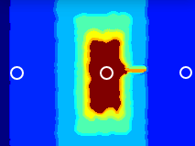

Figure : Visualisation of depth data in hallway

In a larger environment, the ability to walk in each direction is discernible from the delays in each audio pointer. Once a wall is approached, it is possible to align oneself with the wall with the information given by the audio pointers; this approach is like the practice of “shorelining” seen with practitioners of echolocation [1], [2].

The addition of obstacle detection has significantly improved the usability of the device. As well as improving the safety of the device by warning the user of immediate, the user can “scan” the environment by moving their head and listening to the obstacle warning beeps; one useful technique in navigating a hallway junction is for the user to rotate their head until they find a point where the obstacle warning system no longer produces warnings, indicating an opening. The obstacle detection techniques described in the Implementation section produce a reasonable classification of obstacles, and a subjectively low false-positive rate.

## Software Performance

The software implementation, when considered against the proposed implementation, has been mostly successful. Audio playback is clear, loud, and without “pops” or other audio artefacts. The audio latency is subjectively low – if the USB pointer button is depressed with an object directly in front of the user, the audio is heard almost immediately.

Other usability metrics were also considered. The boot time, as measured from the time the device is powered on to the time its navigational functionality is usable was measured as 70 seconds. The startup sound is therefore useful in alerting the user when the software is ready to use. The software is stable and does not “crash” or “hang” except in low power conditions.

The system also has no method for “safely” powering down the device – the device is switched off by either removing the USB power cable, or by allowing the battery to run down. The Raspberry Pi documentation cautions that this may cause SD card corruption [28], although this was not an issue during testing the device.

While implementing the image processing pipeline, one of the most important considerations was the amount of time elapsed between the user triggering the device and sound being played. With the addition of the obstacle warning system, speed of the pipeline became even more important, since the time between encountering an obstacle and a warning sound being played should be as small as possible for the warning to be effective.

The final implementation of the pipeline takes approximately 180-220ms to complete on the Raspberry Pi. Testing has shown this to be adequate for giving reasonably fast responses to environmental changes; however, performance improvements here would open the opportunity for more sophisticated processing – for example, recognising individual obstacles. Additionally, the Raspberry Pi device was found to throttle its frequency from 1.4GHz to 600MHz in high-use scenarios – this is discussed further in the Thermal Management subsection.

## Physical Device

As per the specifications provided in the Hardware Implementation section, the device is powered by a 10,000mAh USB power bank, allegedly providing up to 2.5A at 5V. Usage testing was performed by powering the unit on with a full battery charge and using the pointer to trigger the depth capture and audio playback for a period of 30 seconds every 10 minutes. This usage pattern combines power usage when being both actively used and idle.

Despite the addition of the low-power mode, power usage remains problematic. Power usage was tested by using the device in low-power mode, while switching to active use for 2 minutes every 30 minutes. Overall longevity of the device was improved to provide several hours on battery in low-power mode; however, after approximately 45 minutes the device experienced full reboots when attempting to use the camera. It is possible that the USB power supply utilised struggles to provide the current required to switch the camera off and on under some circumstances.

## Comfort

As highlighted in the literature review, the comfort of such a device is a key concern. As implemented, using the headphones provided, the device does not stop the user from hearing other environmental audio, and its on-demand nature reduces the possible annoyance of persistent sounds generated by the device, as does the unobtrusiveness of the sound produced.

Physically, the device is generally easy to use. However, the cable management and portability of the device could be improved, perhaps with a belt mount or holster for the Raspberry Pi unit, instead of requiring a pocket. Additionally, while the headphones have a cushion for the strap across the top of the head, the additional weight of the camera and the downwards pressure of the camera’s USB cable can be uncomfortable after extended use. The USB pointer is easy to use and comfortable, aided by its cordless nature. The buttons have a physical “click” when they have activated, giving clear feedback to the user.

## Limitations

As highlighted in the project proposal, several limitations exist with the device as specified and implemented:

* Infrared time-of-flight cameras have been shown to exhibit errors in environments with highly specular surfaces as seen in the test data, and sources of infrared interference such as the sun, other infrared cameras, or incandescent lights. This may limit the device’s usefulness outdoors or other situations with infrared interference;
* Infrared time-of-flight cameras also cannot distinguish the presence of many transparent materials such as sheets of glass;
* This design does not, and makes no effort to, distinguish the type of obstacle – it only indicates that an obstacle is present;
* The design concentrates on obstacles visible at the horizon. It is assumed that “trip hazards” will be detected by use of a cane (cane use in combination with other navigational techniques is covered in the Literature Review section).
* The effectiveness of the device may be affected if the camera is not mounted in proper alignment with the user’s head, or is knocked during use;
* If the user moves after triggering the device but before the sounds are played for obstacles, the delay or position in stereo space of the sounds will not be updated – if the user moves their head, for example, the sounds will not be panned to accommodate this change. However, this is largely mitigated by the obstacle warning system.

# Future Work

## Implementation Improvements

The current implementation is extremely rudimentary in its approach in processing the depth frame. The purpose of the current implementation is merely to provide the foundation for more sophisticated techniques. Several such techniques for improvement are given below. Consideration for performance must be given when implementing more advanced processing techniques – as highlighted, the device is reliant on low latency between the user pressing the USB pointer button and sounds being played.

### More Sophisticated Stereo Sound

The original concept of the device proposed playback of many audio localisation pointers, perhaps up to 20, with the user given a more detailed impression of the environment. Testing showed that with the constant power panning technique implemented in the device, differentiation of angles in stereo was sometimes difficult, even with only 3 samples. For this reason, the azimuth of the audio pointers is exaggerated to allow the user to differentiate left from right and centre easily.

It is possible that with more sophisticated stereo sound playback, the user may be able to better differentiate sounds at different azimuths. Existing applications for stereo sound playback where the azimuth differentiation is important such as video games tend to use Head-Related Transfer Functions [13] (often in addition to other techniques). Transfer functions to approximate inter- and intra-aural differences experienced by humans are freely available and can be applied convolutionally to an audio stream. Implementation of an HRTF in the device as a next step is therefore highly recommended, and would allow further experimentation with audio localisation pointers.

### Other Filtering Approaches

While the current filtering pipeline of a median filter and hole-filling filter gives reasonable results, there are other filtering approaches that could be investigated which may give improved results, either as part of this project or as an extension.

An image-guided filtering approach was investigated due to the availability of RGB images from the Intel RealSense camera implemented in later versions of the firmware. Image-guided filters utilise a reference image to “guide” a lower-level filter such as a bilateral filter, giving better edge-preserving results than just a bilateral filter on its own [29]. The image-guided filter presented in [29] is linear with performance independent from the kernel size, which may make it more suited to real-time processing.

While Intel’s documentation claims that “impressive” results have been achieved guiding filtering of the depth image using the RGB image, no reference implementation is given [22]. Testing has shown that the RGB and depth images on the D435i differ in field of view significantly, and therefore “registration” (automatically matching pixel positions from one image to another) would be required before the RGB image could be used to guide the filtering. Additionally, while the depth camera gives good results in low-light situations, the RGB camera does not, which would reduce the performance of this filtering approach.

Finally, it may be worthwhile to investigate adaptive approaches such as adaptive mean or adaptive median filtering. These approaches have the benefit of maintaining more edge detail by filtering sections of the image with high intensity variance (e.g. edges) less aggressively than sections of the image with low variance [23]. However, these approaches may decrease the suppression of impulse noise and discontinuities.

### Thermal Management

Testing has shown that after using the device actively for a long period of time, the Raspberry Pi reduces its CPU frequency from 1.4GHz to 600MHz as measured using cat /sys/devices/system/cpu/cpu0/cpufreq/scaling_cur_freq. This reduction of frequency causes an almost linear reduction to the performance to the image processing pipeline, increasing the time to complete the task to approximately 400ms. This has significant implications for device usability.

It is likely that this frequency reduction is part of the RPi’s thermal management approach [30]. A preventative approach has been taken to resolving this issue by reducing CPU usage where possible, as per the power usage improvements outlined. However, it is likely that this issue would be reduced further by installing cooling hardware in the device such as a passive heatsink.

## Physical Device and Usability Improvements

### Construction Improvements

Currently, the device must be held in the pocket, which can prove awkward. This could be improved by using a belt clip or holster; better cable management would help prevent cables snagging on obstacles. The headphones can become quite uncomfortable after extended use due to the additional weight of the camera – this might be able to be improved by making the mount for the camera larger to spread the weight across more of the headphones, or in providing additional padding for the head rest of the headphones.

### Raspberry Pi 4

During the implementation of this project the Raspberry Pi 4 was released. Due to time constraints, no attempt to migrate the project to the RPi 4 was made. Additionally, as of November 2019, the RPi 4 is not officially supported by the Intel RealSense SDK. The RPi 4 has several performance improvements including an upgraded ARM Cortex-A72 1.5GHz CPU[19] which would assist in allowing the image processing pipeline to complete faster and introduce opportunities for more sophisticated processing techniques.

### Full Light Performance

Performance of the RealSense D435i camera in full light is claimed to be equivalent or superior to performance in low-light scenarios [31]. However, it appears that a recent firmware update has introduced a regression in performance in full-light scenarios [21]. This regression causes the RealSense pipeline to produce depth frames with little or no depth information after using the unit outdoors, even if the user returns to a low-light scenario. Figure 23 shows the output of the camera before and after using the unit outdoors. Intel have been contacted and have provided an updated version of the framework, however as of November 2019 this updated version of the framework has significant issues when used over USB2.1 with the D435i camera tested.

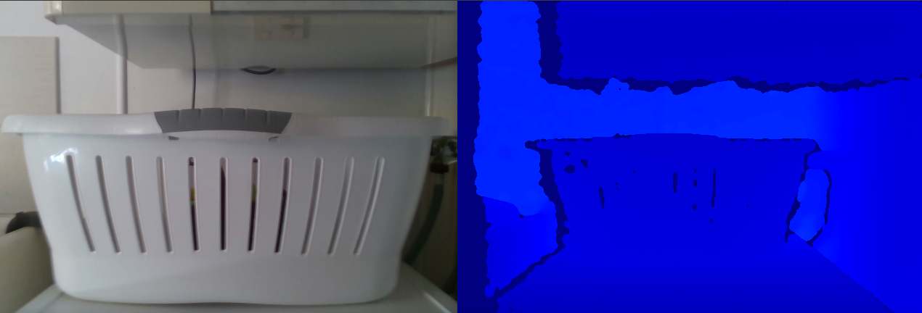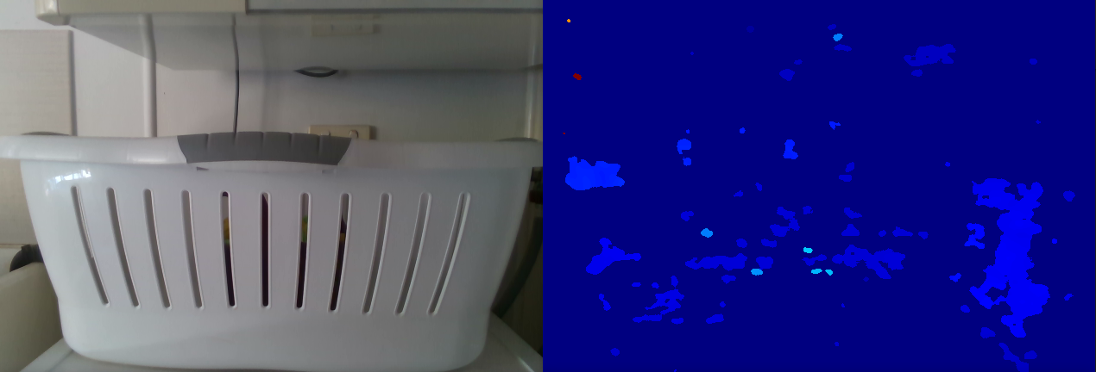

Figure : Top: colour and depth images captured indoors; bottom: colour and depth images captured after using the unit in full sun

# Project Management Methodology

Due to the strict timelines in place for the project, a project management methodology was outlined in the project proposal and carried through the duration of the project. This section will describe the major deliverables and milestones within the project, and the project plan which will were utilised as a guide to produce these deliverables. However, due to the experimental nature of the project, much of the design work is iterative, and implementation priorities were subject to change based on results produced during implementation, and guidance from the project supervisors and technical peers.

## First Semester Schedule Progress

The original schedule for the first semester of work highlighted key deliverables, and proposed milestone dates for achievement of these deliverables. The proposed Gantt chart for the first semester is presented unaltered in Appendix A – Semester 1 Gantt Chart. The deliverables have been completed within the scheduled time, and the schedule did not require drastic revision. A summary of the key stages and deliverables is given in Figure 24.

Figure : Semester 1 stages

The first phase of the project was not without setbacks. Significantly, the evaluation and iteration processes were impacted moderately with a lengthy difficulty in configuring the Linux environment for Raspberry Pi to output stereo sound – a seemingly simple task, but one that is vital to the performance of the device. This risk could have been mitigated earlier with a more thorough risk analysis.

Other delays included the compilation and linking process for large libraries on Raspberry Pi. This was recognised as a possible risk early in the project, but still consumed several days of time, during which the Raspberry Pi device was unusable. Additional time was lost when the original Raspberry Pi device was destroyed; fortunately, the data was able to be transferred once a new unit was sourced.

Much of the implementation time was spent on sound production in Linux. ALSA is a low-level library, and implementing real-time playback using ALSA without errors or crashes took a significant amount of time. However, in doing so, much experience in dealing with Linux, C APIs, and C datatypes was gained.

Overall, the schedule as proposed was successful, and left ample time for implementation of the first stage of the project.

## Second Semester Progress

Figure : Semester 2 stages

The second semester has produced many of the proposed deliverables successfully: namely, the image processing pipeline has been drastically overhauled, and the obstacle warning system has been successfully implemented. However, the schedule has experienced several setbacks.

Some issues encountered include:

* RealSense device inoperability following a mandatory software update requiring significant troubleshooting;
* Segmentation has proven to be far more complex than initially understood;
* Expansion of scope to include real-time elements;
* Significant time pressures outside the context of the unit which have been registered with the faculty.

Ultimately, much of the time laid out for further experimentation with image processing has been utilised for the core project deliverables. Additionally, the user testing program proposed in the original outline has been omitted due to time constraints. However, time issues were recognised early in the semester, and were discussed with the supervising team throughout. Adjustments were made to the deliverables to ensure that a satisfactory result could be produced.

The full updated Gantt chart is presented in Appendix B – Semester 2 Gantt Chart.

# Conclusions

A design and prototype for a device to enhance situational awareness and navigational ability of the vision impaired has been presented. This device has been successful in implementing synthesis of the depth camera, input, and sound output using ALSA. The use of delay to signify distance from the user is successful and intuitively understood. Localisation of audio pointers using constant power panning has struggled to provide adequate separation of the audio in stereo; this is mitigated by exaggerating the angular separation.

Experimentation for processing depth frames, including filtering and segmentation, to assist the production of audio localisation pointers and obstacle warning tones are described. These techniques have been moderately successful and complete within 200ms on Raspberry Pi 3 B+ hardware. The obstacle detection tones enhance the navigational and safety performance of the device.

The physical prototype of the device has been moderately successful. It is portable and easy to use; however, the power usage of the device is excessive, and various usability factors such as boot time and device comfort could be improved. An investigation of power and CPU usage is presented, and improvements have been implemented, however further work in this area would be beneficial.

The project has been implemented to the specification and schedule presented in the project proposal. Delays have been experienced as the project moves into more advanced areas of implementation. The second semester schedule has been expanded and clarified to include the bodies of work that emerged from experimentation in Semester 1, and a work breakdown structure including timeframes is presented in the Gantt chart.

# References

[1] M. A. Williams, C. Galbraith, S. K. Kane, and A. Hurst, “‘Just Let the Cane Hit It’: How the Blind and Sighted See Navigation Differently,” in *Proceedings of the 16th International ACM SIGACCESS Conference on Computers & Accessibility*, New York, NY, USA, 2014, pp. 217–224.

[2] S. Teng, “Human Echolocation,” Ph.D., University of California, Berkeley, United States -- California, 2013.

[3] T. Inagaki *et al.*, “Experimental observations on the optimal layout of orientation blocks for safe road crossing by the visually impaired,” *IATSS Res.*, vol. 41, no. 2, pp. 82–88, Jul. 2017.

[4] “Tactile paving,” *Wikipedia*. 01-Apr-2019.

[5] L. Thaler, “Echolocation may have real-life advantages for blind people: an analysis of survey data,” *Front. Physiol.*, vol. 4, May 2013.

[6] T. C. Davies and S. D. Pinder, “Spatial Orientation Using Echolocation — Characterising Signals for Downconversion,” *Proc. Hum. Factors Ergon. Soc. Annu. Meet.*, vol. 49, no. 11, pp. 1009–1013, Sep. 2005.

[7] “About the UltraCane.” [Online]. Available: https://www.ultracane.com/about_the_ultracane. [Accessed: 14-Apr-2019].

[8] K. Yang, K. Wang, W. Hu, and J. Bai, “Expanding the Detection of Traversable Area with RealSense for the Visually Impaired,” *Sensors*, vol. 16, no. 11, p. 1954, Nov. 2016.

[9] J. Wang, K. Yang, W. Hu, and K. Wang, “An Environmental Perception and Navigational Assistance System for Visually Impaired Persons Based on Semantic Stixels and Sound Interaction,” in *2018 IEEE International Conference on Systems, Man, and Cybernetics (SMC)*, 2018, pp. 1921–1926.

[10] L. Dunai, I. Lengua, G. Peris-Fajarnés, and F. Brusola, “Virtual Sound Localization by Blind People,” *Arch. Acoust.*, vol. 40, no. 4, pp. 561–567, Dec. 2015.

[11] J. Sohl-Dickstein *et al.*, “A Device for Human Ultrasonic Echolocation,” *IEEE Trans. Biomed. Eng.*, vol. 62, no. 6, pp. 1526–1534, Jun. 2015.

[12] C. Urbanietz and G. Enzner, “Binaural Rendering for Sound Navigation and Orientation,” in *2018 IEEE 4th VR Workshop on Sonic Interactions for Virtual Environments (SIVE)*, 2018, pp. 1–5.

[13] V. R. Algazi and R. O. Duda, “Headphone-Based Spatial Sound,” *IEEE Signal Process. Mag.*, vol. 28, no. 1, pp. 33–42, Jan. 2011.

[14] M. Geronazzo, A. Bedin, L. Brayda, C. Campus, and F. Avanzini, “Interactive spatial sonification for non-visual exploration of virtual maps,” *Int. J. Hum.-Comput. Stud.*, vol. 85, pp. 4–15, Jan. 2016.

[15] “3D Audio Spatialization,” *Oculus*. [Online]. Available: https://developer.oculus.com/documentation/audiosdk/latest/concepts/audio-intro-spatialization/. [Accessed: 14-Apr-2019].

[16] “Loudness Concepts & Panning Laws,” *Carnegie Mellon University*. [Online]. Available: https://www.cs.cmu.edu/~music/icm-online/readings/panlaws/index.html. [Accessed: 13-Apr-2019].

[17] “Raspberry Pi 3 Model B+,” *Raspberry Pi*. [Online]. Available: https://www.raspberrypi.org/products/raspberry-pi-3-model-b-plus/. [Accessed: 13-Apr-2019].

[18] “Intel® RealSenseTM D400 cameras with Raspberry Pi,” 12-Apr-2019. [Online]. Available: https://github.com/IntelRealSense/librealsense/blob/master/doc/RaspberryPi3.md. [Accessed: 13-Apr-2019].

[19] “Buy a Raspberry Pi 4 Model B,” *Raspberry Pi*. [Online]. Available: https://www.raspberrypi.org. [Accessed: 06-Sep-2019].

[20] “Raspberry Pi 4 Review: The New Gold Standard for Single-Board Computing - Tom’s Hardware.” [Online]. Available: https://www.tomshardware.com/reviews/raspberry-pi-4-b,6193.html. [Accessed: 06-Sep-2019].

[21] Intel, “RealSense D400 Series Spec Update.” [Online]. Available: https://www.intel.com/content/dam/support/us/en/documents/emerging-technologies/intel-realsense-technology/RealSense-D400-Series-Spec-Update.pdf. [Accessed: 07-Sep-2019].

[22] Grunnet-Jepsen, Anders and Tong, Dave, “Depth Post-Processing for Intel® RealSenseTM D400 Depth Cameras.” [Online]. Available: https://dev.intelrealsense.com/docs/depth-post-processing. [Accessed: 07-Sep-2019].

[23] R. C. Gonzalez and R. E. Woods, *Digital Image Processing*, 4th ed. New York: Pearson.

[24] “Image Filtering,” *OpenCV*. [Online]. Available: https://docs.opencv.org/2.4/modules/imgproc/doc/filtering.html?highlight=laplacian#laplacian. [Accessed: 30-Oct-2019].

[25] C. E. Shannon, “Communication in the Presence of Noise,” *Proc. IEEE*, vol. 86, no. 2, p. 11, 1998.

[26] S. Rosen, P. Howell, and J. F. Bartram, “Signals and Systems for Speech and Hearing,” *J. Acoust. Soc. Am.*, vol. 94, no. 6, pp. 3530–3530, Dec. 1993.

[27] “IEC 60908:1987 Compact disc digital audio system.” 1987.

[28] “FAQs - Raspberry Pi Documentation,” *Raspberry Pi*. [Online]. Available: https://www.raspberrypi.org/documentation/faqs/#pi-power. [Accessed: 04-Jun-2019].

[29] K. He, J. Sun, and X. Tang, “Guided Image Filtering,” presented at the Computer Vision-ECCV 2010, 2010.

[30] “Frequency management and thermal control.” [Online]. Available: https://www.raspberrypi.org/documentation/hardware/raspberrypi/frequency-management.md. [Accessed: 02-Nov-2019].

[31] “Depth Camera D435i,” *Intel® RealSenseTM Depth and Tracking Cameras*. [Online]. Available: https://www.intelrealsense.com/depth-camera-d435i/. [Accessed: 14-Apr-2019].

# Appendix A – Semester 1 Gantt Chart

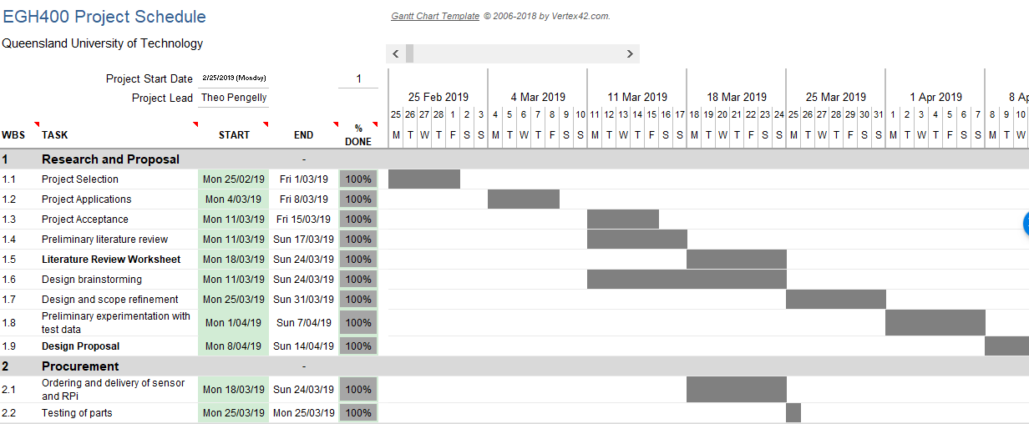

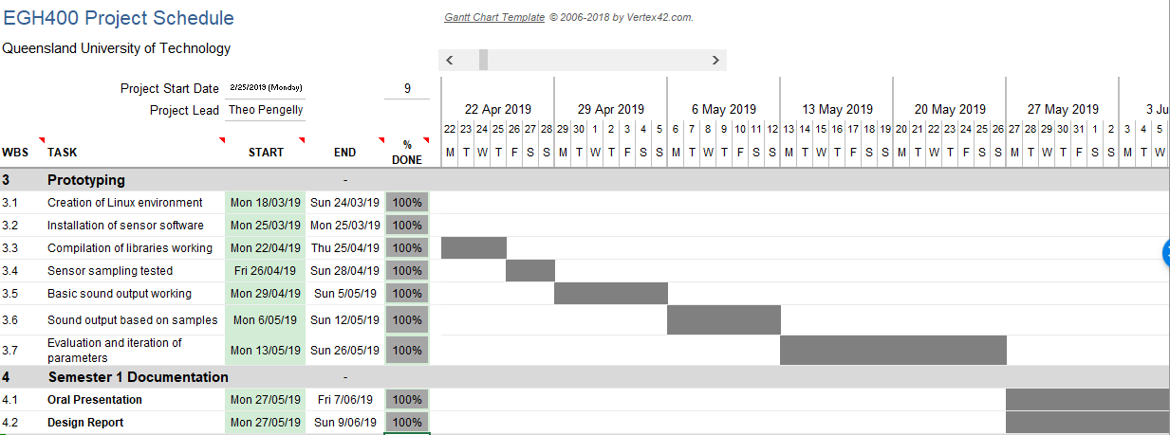

# Appendix B – Semester 2 Gantt Chart

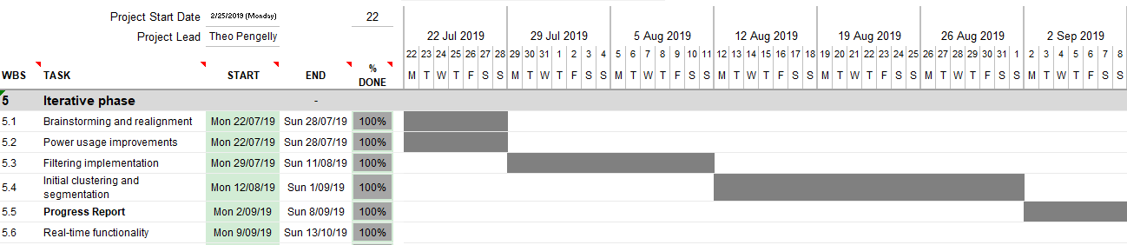

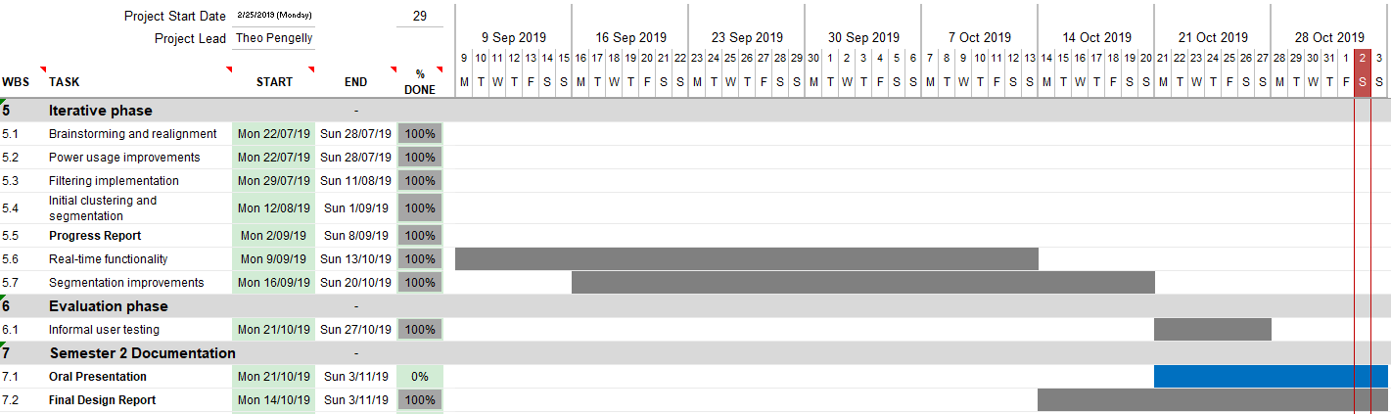

# Appendix C – Code

Full code and build instructions can be found at <https://github.com/theodop/thesis>

1. Converted from $199 USD at $1AUD = $0.698USD
2. In computer science terms, a “thread” is a section of code which is scheduled independently of other threads by the operating system through either time-slicing or concurrent execution (if possible). Multiple threads within the same process may share the same memory (i.e. variables).